UNITED STATES
SECURITIES AND EXCHANGE COMMISSION
Washington, D.C. 20549

FORM 8-K

CURRENT REPORT
PURSUANT TO SECTION 13 OR 15(d)
OF THE SECURITIES EXCHANGE ACT OF 1934
Date of Report (Date of earliest event reported): October 23, 2026

TANGO THERAPEUTICS, INC.
(Exact name of registrant as specified in its charter)

Delaware |  | 001-39485 |  | 85-1195036
(State or other jurisdiction  of incorporation) |  | (Commission  File Number) |  | (IRS Employer  Identification No.)

201 Brookline Ave., Suite 901  Boston, MA |  | 02215
(Address of principal executive offices) |  | (Zip code)
Registrant’s telephone number, including area code: 857-320-4900
N/A
(Former name or former address, if changed since last report)

Check the appropriate box below if the Form 8-K filing is intended to simultaneously satisfy the filing obligation of the registrant under any of the following provisions (see General Instruction A.2. below):

☐ | Written communications pursuant to Rule 425 under the Securities Act (17 CFR 230.425)

☐ | Soliciting material pursuant to Rule 14a-12 under the Exchange Act (17 CFR 240.14a-12)

☐ | Pre-commencement communications pursuant to Rule 14d-2(b) under the Exchange Act (17 CFR 240.14d-2(b))

☐ | Pre-commencement communications pursuant to Rule 13e-4(c) under the Exchange Act (17 CFR 240.13e-4(c))
Securities registered pursuant to Section 12(b) of the Act:

Title of each class |  | Trading  Symbol(s) |  | Name of each exchange  on which registered
Common stock, par value $0.001  per share |  | TNGX |  | The Nasdaq Global Market
Indicate by check mark whether the registrant is an emerging growth company as defined in Rule 405 of the Securities Act of 1933 (§230.405 of this chapter) or Rule 12b-2 of the Securities Exchange Act of 1934 (§240.12b-2 of this chapter).
Emerging growth company ☐
If an emerging growth company, indicate by check mark if the registrant has elected not to use the extended transition period for complying with any new or revised financial accounting standards provided pursuant to Section 13(a) of the Exchange Act. ☐

Item 7.01. | Regulation FD Disclosure.
On October 23, 2026, Tango Therapeutics, Inc. (the “Company”) issued a press release announcing updated results from the Company’s ongoing Phase 1/2 clinical trial evaluating vopimetostat in combination with RAS(ON) inhibitors from Revolution Medicines, Inc.
A copy of the press release is attached as Exhibit 99.1 to this Current Report on Form 8-K and incorporated herein by reference. A copy of the presentation relating to the updated results from the Phase 1/2 trial is attached as Exhibit 99.2 to this Current Report on Form 8-K and incorporated herein by reference.
The information in this Item 7.01, including Exhibits 99.1 and 99.2 of this Current Report on Form 8-K, are furnished and shall not be deemed to be “filed” for the purposes of Section 18 of the Securities Exchange Act of 1934, as amended (the “Exchange Act”), or otherwise subject to the liabilities of that section. The information in this Item 7.01 and Exhibits 99.1 and 99.2 of this Current Report on Form 8-K shall not be incorporated by reference into any filing under the Securities Act of 1933, as amended, or the Exchange Act, whether made before or after the date of this Current Report on Form 8-K, regardless of any general incorporation language in any such filing.

Item 8.01. | Other Events.
Promising Results from Phase 1/2 Clinical Trial of Vopimetostat in Combination with RAS(ON) Inhibitors
On October 23, 2026, the Company disclosed promising results from its ongoing Phase 1/2 trial evaluating vopimetostat in combination with RAS(ON) inhibitors from Revolution Medicines, Inc. in patients with MTAP-deleted and RAS-mutant metastatic pancreatic ductal adenocarcinoma (“PDAC”) and non-small cell lung cancer (“NSCLC”).
As of the data cutoff date of August 20, 2026, updated data from the ongoing Phase 1/2 study demonstrated an 82% objective response rate (“ORR”), median progression-free survival (“PFS”) not yet reached, and a 9-month PFS rate of 88% in 22 patients with second line or third line MTAP-deleted/RAS-mutant PDAC who were efficacy-evaluable. The combination was generally well-tolerated in the 30 PDAC and NSCLC patients who received dose level 1.
Vopimetostat plus Daraxonrasib
As of the data cutoff date of August 20, 2026, 34 patients with previously treated MTAP-deleted and RAS-mutant PDAC (n=29) or NSCLC (n=5) were treated with vopimetostat plus daraxonrasib. The majority of PDAC patients (13 of 22 patients) who were efficacy-evaluable received the combination as third-line treatment. Efficacy-evaluable patients are those patients who received their first dose of treatment at least 14 weeks prior to the data cutoff date.
In the vopimetostat plus daraxonrasib dose escalation arm, efficacy-evaluable patients received either vopimetostat 200 mg (n=19; dose level 1) or 250 mg (n=3; dose level 2) once daily (“QD”) plus daraxonrasib 100 mg QD. As of the data cutoff date of August 20, 2026, 22 patients were efficacy-evaluable, with median follow up of 7.1 months (range: 3.3-12.5 months).
In efficacy-evaluable PDAC patients with MTAP-deleted, RAS-mutant PDAC, the Company observed an ORR of 82% (18 of 22 patients, with 11 of 18 confirmed partial responses (“cPRs”) and 7 unconfirmed partial responses with all unconfirmed responses confirmed after the data cutoff date). Median PFS has not yet been reached. The Company also observed an 88% 9-month PFS rate and a 100% disease control rate (“DCR”).

Dose level 1 (n=25 safety-evaluable patients) of the vopimetostat plus daraxonrasib combination in PDAC patients was generally well-tolerated as of the data cutoff date. There were no dose-limiting toxicities (“DLTs”) and no withdrawals due to treatment-related adverse events (“TRAEs”). There were no Grade 4 or 5 TRAEs and the rate of Grade 3 TRAEs was 40% (10 of 25 patients). The most common TRAEs were Grade 1 or 2 stomatitis (48%), rash (44%), and diarrhea (28%). Dose level 2 (n=4 safety-evaluable patients) of the vopimetostat plus daraxonrasib combination in PDAC patients was not well-tolerated and there were 3 DLTs in 2 patients at this dose level.
Safety evaluable patients are those who received at least one dose of the applicable combination prior to the data cutoff date.
In NSCLC patients, the Company observed an ORR of 80% (4 of 5 patients, all of whom had cPRs) at dose level 1 and a 100% DCR.
The vopimetostat plus daraxonrasib combination in NSCLC patients (n=5 safety-evaluable patients) had no Grade 4 or 5 TRAEs and the rate of Grade 3 TRAEs was 20% (1 of 5 patients). The most common TRAEs in NSCLC safety-evaluable patients were Grade 1 or 2 rash (100%), diarrhea (80%), stomatitis (40%), nausea (40%), and fatigue (40%).
Vopimetostat plus Zoldonrasib
In the vopimetostat plus zoldonrasib dose escalation arm, PDAC patients with MTAP deletion and KRAS G12D mutation received vopimetostat 200 mg or 250 mg QD plus zoldonrasib 600 mg or 1200 mg QD across four dose levels (dose level 1: 200 mg/600 mg QD; dose level 2: 250 mg/600 mg QD; dose level 3: 250 mg/1200 mg QD; and dose level 4: 200 mg/1200 mg QD). As of the data cutoff date of August 20, 2026, 35 patients were efficacy-evaluable, meaning that they received their first dose of treatment at least 14 weeks prior to the data cutoff date. 39 patients were safety-evaluable, meaning they received at least one dose of this combination prior to the data cutoff date.
The Company observed an ORR of 54% (19 of 35 patients, with 18 cPRs and one confirmed complete response as of the data cutoff date) across all dose levels in the zoldonrasib plus vopimetostat arm. The Company also observed a 61% 9-month PFS rate and a 97% DCR in these patients.
The vopimetostat plus zoldonrasib combination was generally well-tolerated across dose levels. There were no DLTs and no withdrawals due to TRAEs. The rate of dose reduction was 15% (6 of 39 patients). There were no Grade 5 TRAEs and there was one Grade 4 TRAE (3%). The rate of Grade 3 TRAEs was 28% (11/39 patients). The most common TRAEs were Grade 1 or 2 nausea (39%), vomiting (39%), dysgeusia (28%), and fatigue (26%).
Regulatory Update
Following recent interactions with the U.S. Food and Drug Administration (“FDA”), the Company plans to initiate a global, randomized registrational trial evaluating the combination of vopimetostat with daraxonrasib in front-line patients with MTAP-deleted PDAC. The planned study will randomize patients 1:1 to receive either vopimetostat (200 mg once daily) plus daraxonrasib (100 mg once daily) or standard-of-care chemotherapy. The dual primary endpoints of the planned study are ORR and PFS, with overall survival as a key secondary endpoint. The Company anticipates initiating this study in the first half of 2027. The Company is pursuing multiple pathways to obtain clinical supply of daraxonrasib for the planned study. In addition, the Company intends to discuss the possibility of seeking approval of this combination in patients with second line PDAC with regulatory authorities.

Clinical Update
The Company now expects to report data from its Phase 1/2 clinical trial of vopimetostat monotherapy in a cohort of patients with NSCLC in January 2027 and data from its Phase 1/2 clinical trial evaluating TNG456 as a monotherapy in NSCLC, glioblastoma, and other cancers in January 2027.
Strategic Reprioritization
On October 22, 2026, the Board of Directors of the Company approved a strategic reprioritization of the Company’s research and development activities to focus its efforts on the advancement of PRMT5-targeted therapies and the Company’s clinical product candidates, vopimetostat and TNG456, and to deprioritize novel target discovery (the “Plan”). In connection with the Plan, the Company intends to stop certain preclinical and research activities to focus on translational work and its PRMT5 programs, including a planned Phase 1/2 vopimetostat + RAS combination study in second line MTAP-wild type PDAC, which the Company plans to initiate in the first half of 2027. As part of the Plan, the Company intends to reduce its overall workforce by approximately 14%, with the majority of the headcount reductions from the Company’s research group.
Forward-Looking Statements
This Current Report on Form 8-K and certain materials furnished or filed herewith contain forward-looking statements within the meaning of the Private Securities Litigation Reform Act of 1995, as amended. All statements other than statements of historical fact are statements that could be deemed forward-looking statements, including all statements regarding the intent, belief, or current expectation of the Company and members of the Company’s senior management team. Forward-looking statements are not purely historical and may be accompanied by words such as “may”, “should”, “expect”, “intend”, “will”, “goal”, “estimate”, “anticipate”, “believe”, “predict”, “designed,” “potential” or “continue”, or the negatives of these terms or variations of them or similar terminology. For example, implicit or explicit statements concerning the following include or constitute forward-looking statements: (i) the potential of the Company’s PRMT5 molecules, as both standalone treatments and in combination with RAS(ON)-inhibitors, including the Company’s belief that vopimetostat (TNG462) has the potential to assist in treating patients with MTAP-deleted cancers; (ii) the preclinical research of the Company’s PRMT5 inhibitors, as a monotherapy and in combination, and the expectation that they may pave the way for future development opportunities, including expectations that vopimetostat (and its combination with RAS(ON) inhibitors), may be an important new therapy for MTAP-deleted cancers; (iii) expectations regarding the anticipated benefits of the Company’s molecules, development candidates, and product candidates; (iv) expectations for vopimetostat and the belief that vopimetostat has the potential to be a first- and best-in-class PRMT5 inhibitor for the treatment of MTAP-deleted cancers; (v) the Company’s development strategy in PRMT5-targeted therapies, including the ability of the Company’s vopimetostat clinical trials to inform a potential registrational trial in pancreatic cancer and the exploration of a vopimetostat RAS combination in MTAP wild-type tumors; (vi) the Company’s beliefs regarding the timing of upcoming clinical milestones and data disclosures, including, but not limited to: (a) the expected timing of clinical trial initiation, enrollment, dose escalation or dose expansion (including for combination studies) and (b) the expected timing of disclosing initial, interim, updated, additional, and final clinical trial results (including for combination studies); (vii) the Company’s plans, study design, doses, endpoints, and timing for combination trials, including the planned Phase 3 clinical trial evaluating vopimetostat with daraxonrasib in front-line patients with MTAP-deleted PDAC anticipated to be initiated in the first half of 2027; (viii) the Company’s expectations around regulatory communications and decisions related to its product candidates and clinical trials (including combination studies), including interactions with the FDA and other regulatory authorities; and (ix) the Company’s expectations regarding its ability to secure sufficient clinical supply of daraxonrasib for its

planned Phase 3 clinical trial evaluating vopimetostat with daraxonrasib. Such forward-looking statements are subject to risks, uncertainties, and other factors which could cause actual results to differ materially from those expressed or implied by such forward-looking statements. These forward-looking statements are based upon estimates and assumptions that, while considered reasonable by the Company and its management, are inherently uncertain. New risks and uncertainties may emerge from time to time, and it is not possible to predict all risks and uncertainties. Factors that may cause actual results to differ materially from current expectations include, but are not limited to: the benefits of product candidates, as single agents and/or in combination seen in preclinical tests and analyses and current and future clinical trials may not be evident or may differ materially when tested in later preclinical studies or in clinical trials or when used in broader patient populations (if approved for commercial sale); the Company’s effectiveness in managing current and future clinical trials, including maintaining anticipated timelines and reporting clinical trial results in the anticipated timeframe (or at all); the Company’s reliance on third parties for conducting clinical trials and supplying and producing drug substance and drug product; expectations regarding the benefits and success of current or future collaborations and combination clinical trials; the Company’s ability to enter into additional collaboration and supply agreements and to acquire, license, or otherwise obtain rights to additional products, product candidates, or molecules; the Company’s pipeline products may not be safe and/or effective in humans; the Company’s ability to raise capital in the future and the potential delay, scale back or discontinuation of some of its development programs or future commercialization efforts if such funding is not available on acceptable terms (or at all); the Company’s product candidates may cause adverse or other undesirable side effects (or may not show requisite efficacy) that could, among other things, delay or prevent regulatory approval; government regulation, including inadequate funding for or disruptions at the FDA or other government agencies, may adversely affect the Company’s business. Additional information concerning risks, uncertainties and assumptions can be found in the Company’s filings with the Securities and Exchange Commission (“SEC”), including the risk factors referenced in the Company’s Annual Report on Form 10-K for the fiscal year ended December 31, 2025, as well as other filings the Company makes with the SEC from time to time. You should not place undue reliance on forward-looking statements in this Current Report on Form 8-K and certain materials furnished or filed herewith, which speak only as of the date they are made and are qualified in their entirety by reference to the cautionary statements herein. The Company specifically disclaims any duty to update these forward-looking statements.

Item 9.01. | Financial Statements and Exhibits.

(d) | Exhibits

Exhibit  No. |  | Description
99.1 |  | Press Release of Tango Therapeutics, Inc., dated October 23, 2026
99.2 |  | Presentation of Tango Therapeutics, Inc., dated October 23, 2026
104 |  | Cover Page Interactive Data File (embedded within Inline XBRL document)

SIGNATURES
Pursuant to the requirements of the Securities Exchange Act of 1934, the registrant has duly caused this report to be signed on its behalf by the undersigned hereunto duly authorized.

 |  |  |  | TANGO THERAPEUTICS, INC.
Dated: October 23, 2026 |  |  |  | By: |  | /s/ Matthew Gall
 |  |  |  | Name: |  | Matthew Gall
 |  |  |  | Title: |  | Chief Financial Officer
Exhibit 99.1
Tango Presents Promising Results from Phase 1/2 Study of Vopimetostat and Daraxonrasib in Pancreatic Cancer and Provides Updates to Development Strategy
82% objective response rate, median progression-free survival (PFS) not yet reached, and 9-month PFS-rate of 88% in patients with 2L/3L pancreatic cancer treated with vopimetostat plus daraxonrasib
Vopimetostat combinations with RAS(ON) inhibitors daraxonrasib or zoldonrasib continued to be generally well-tolerated
Registrational Phase 3 study of vopimetostat plus daraxonrasib in front-line patients with MTAP-deleted pancreatic cancer expected to be initiated in 1H 2027
Investor webcast focused on PDAC to be held today at 7:30 a.m. ET
BOSTON, October 23, 2026 (GLOBE NEWSWIRE) — Tango Therapeutics, Inc. (NASDAQ: TNGX), a clinical-stage biotechnology company committed to delivering breakthrough targeted therapies that extend and improve the lives of patients with cancer, today announced promising results from its ongoing Phase 1/2 study of vopimetostat, an investigational PRMT5 inhibitor with first- and best-in-class potential, in combination with Revolution Medicines’ RAS(ON) inhibitors in patients with MTAP-deleted and RAS-mutant metastatic pancreatic ductal adenocarcinoma (PDAC) and non-small cell lung cancer (NSCLC). The results are being presented at the European Society for Medical Oncology (ESMO) 2026 Congress being held in Madrid, Spain on October 23-27, 2026.
As of the data cutoff date of August 20, 2026, updated data from the ongoing Phase 1/2 study demonstrated an 82% objective response rate (ORR), median PFS not yet reached, and a 9-month PFS rate of 88%, in 22 patients with 2L/3L MTAP-deleted/RAS-mutant PDAC who were efficacy-evaluable. The combination was generally well-tolerated in the 30 PDAC and NSCLC patients who received dose level 1.
“It is encouraging to see that the clinical activity and tolerability observed in our initial June 2026 dataset has been confirmed with longer follow-up and in a larger patient population, affirming our belief that the response rate and durability observed with vopimetostat plus daraxonrasib surpass any published PDAC datasets, even in front-line settings,” said Malte Peters, M.D., Chief Executive Officer and President of Tango Therapeutics. “Following discussions with the U.S. FDA, we are focused on initiating a planned registrational Phase 3 trial of vopimetostat with daraxonrasib in front-line patients with MTAP-deleted pancreatic cancer in the first half of 2027. Given the data generated to date, we view PRMT5 inhibition as an emerging backbone in combination treatment strategies in PDAC and beyond. As a leader in the development of PRMT5-targeted therapies, we are also encouraged by the potential combinations of vopimetostat with RAS inhibitors in MTAP wild-type tumors, which we believe could further expand the impact of PRMT5 inhibition across a broader population of patients with PDAC.”

“For patients with pancreatic cancer, a highly aggressive malignancy that often progresses despite prior treatment, achieving durable disease control remains a significant challenge,” said Alexander Spira, M.D., Co-Director of the Virginia Cancer Specialists Research Institute, NEXT Oncology, an Avacare business, and a principal investigator of the study. “In this updated analysis, the large majority of patients remained progression-free at nine months despite being heavily pretreated, with more than half receiving the combination as third-line therapy. Achieving this level of durability with an oral, chemotherapy-free regimen is particularly meaningful for patients and highlights the potential of a vopimetostat combination to redefine the standard of care in a disease that has been notoriously difficult to treat.”
“The depth and durability of responses reported with the vopimetostat and daraxonrasib combination are encouraging, particularly for patients who had already received multiple lines of treatment. We are excited by the potential of this biomarker-driven, targeted therapy approach and believe these results warrant rapid evaluation in a larger, randomized Phase 3 trial,” said Anna Berkenblit, M.D., MMSc, Chief Scientific & Medical Officer of the Pancreatic Cancer Action Network (PanCAN). “The approval of daraxonrasib marked the beginning of a new era for the pancreatic cancer community after a long wait, and we are looking forward to the next major advance that will translate into meaningful progress for patients quickly.”
Regulatory Update
Following recent interactions with the U.S. Food and Drug Administration (FDA), Tango plans to initiate a global, randomized registrational trial evaluating the combination of vopimetostat with daraxonrasib in front-line patients with MTAP-deleted PDAC. The planned study will randomize patients 1:1 to receive either vopimetostat (200 mg once daily) plus daraxonrasib (100 mg once daily) or standard-of-care chemotherapy. The dual primary endpoints of the planned study are ORR and PFS, with overall survival as a key secondary endpoint. The Company anticipates initiating this study in the first half of 2027.
In addition, the Company intends to discuss the possibility of pursuing approval of this combination in patients with second-line PDAC with regulatory authorities.
Vopimetostat plus daraxonrasib data highlights
As of the data cutoff date of August 20, 2026, 34 patients with previously treated MTAP-deleted and RAS-mutant PDAC (n=29) or NSCLC (n=5) were treated with vopimetostat plus daraxonrasib. The majority of PDAC patients (13/22) who were efficacy evaluable received the combination as third-line treatment. Efficacy-evaluable patients are those patients who received their first dose of treatment at least 14 weeks prior to the data cutoff date.
PDAC
In the vopimetostat plus daraxonrasib dose escalation arm, efficacy-evaluable patients received either vopimetostat 200 mg (n=19; dose level 1) or 250 mg (n=3; dose level 2) once daily (QD) plus daraxonrasib 100 mg QD. As of the data cutoff date of August 20, 2026, 22 patients were efficacy-evaluable, with median follow up of 7.1 months (range: 3.3-12.5 months).
Clinical activity, all dose levels:

 |  |  | 82% ORR (18/22; 11 of 18 confirmed partial responses (cPRs), 7 unconfirmed partial responses; all unconfirmed responses confirmed after the data cutoff date)

 |  |  | Median PFS not yet reached

 |  |  | 88% 9-month PFS

 |  |  | 100% disease control rate (DCR)

Safety and tolerability:

 |  |  | Dose level 1 (n=25 safety-evaluable patients) was generally well-tolerated as of the data cutoff date:

 | ○ |  | There were no dose-limiting toxicities (DLTs)

 | ○ |  | There were no withdrawals due to treatment-related adverse events (TRAEs)

 | ○ |  | The rate of dose reduction was 20% (5/25)

 | ○ |  | There were no Grade 4 or 5 TRAEs

 | ○ |  | The rate of Grade 3 TRAEs was 40% (10/25)

 | ○ |  | The most common TRAEs were stomatitis (48%), rash (44%), and diarrhea (28%); all these events were Grade 1-2

 |  |  | Dose level 2 (n=4 safety-evaluable patients) was not well-tolerated:

 | ○ |  | There were 3 DLTs in 2 patients
Safety-evaluable patients are those who received at least one dose of the applicable combination prior to the data cutoff date.
NSCLC
Clinical activity, dose level 1:

 |  |  | 80% ORR (4/5 cPRs)

 |  |  | 100% DCR
Safety and tolerability, dose level 1:

 |  |  | There were no Grade 4 or 5 TRAEs

 |  |  | The rate of Grade 3 TRAEs was 20% (1/5)

 |  |  | The most common TRAEs were rash (100%), diarrhea (80%), stomatitis (40%), nausea (40%), and fatigue (40%); all these events were Grade 1-2.
Vopimetostat plus zoldonrasib combination (PDAC with MTAP deletion and KRAS G12D mutation)
In the vopimetostat plus zoldonrasib dose escalation arm, patients received vopimetostat 200 mg or 250 mg QD plus zoldonrasib 600 mg or 1200 mg QD across four dose levels (dose level 1: 200 mg/600 mg QD; dose level 2: 250 mg/600 mg QD; dose level 3: 250 mg/1200 mg QD; and dose level 4: 200 mg/1200 mg QD). As of the data cutoff date of August 20, 2026, 35 patients were efficacy-evaluable, meaning that they received their first dose of treatment at least 14 weeks prior to the data cutoff date. 39 patients were safety-evaluable, meaning they received at least one dose of this combination prior to the data cutoff date.
Data highlights include:
Clinical activity, all dose levels:

 |  |  | 54% ORR (19/35; 18 cPRs,1 confirmed complete response)

 |  |  | 61% 9-month PFS

 |  |  | 97% DCR

Safety and tolerability, all dose levels:
Vopimetostat plus zoldonrasib was generally well-tolerated across dose levels:

 |  |  | There were no DLTs

 |  |  | There were no withdrawals due to TRAEs

 |  |  | The rate of dose reduction was 15% (6/39)

 |  |  | There were no Grade 5 TRAEs and there was one Grade 4 TRAE (3%)

 |  |  | The rate of Grade 3 TRAEs was 28% (11/39)

 |  |  | The most common TRAEs were nausea (39%), vomiting (39%), dysgeusia (28%) and fatigue (26%); all these events were Grade 1-2
PDAC-Focused Investor Webcast and Conference Call Information
The Company will host a PDAC-focused webcast to discuss these data at 7:30 a.m. ET today, October 23, 2026. The live webcast can be accessed under “Events & Presentations” in the Investors section of the Company’s website at www.tangotx.com. The webcast will be available for replay for at least 30 days on the Company website. Analysts who wish to join the teleconference and participate in Q&A should register here.
About Vopimetostat
Vopimetostat is an investigational, potentially first- and best-in-class oral, once-daily, PRMT5 inhibitor that is being evaluated as a monotherapy and as a combination therapy in multiple indications. In ongoing clinical studies, vopimetostat has demonstrated a favorable safety and tolerability profile and shown durable activity in multiple tumor types with MTAP (methylthioadenosine phosphorylase) deletion, including pancreatic cancer and lung cancer.
About Phase 1/2 Study of Vopimetostat Combinations with Daraxonrasib or Zoldonrasib
The ongoing Phase 1/2 open-label, dose-escalation and expansion trial is evaluating vopimetostat in combination with either daraxonrasib or zoldonrasib in patients with RAS-mutant, MTAP-deleted PDAC or NSCLC. The primary objective of the dose-escalation portion of the study was to determine the maximum tolerated dose of the combination regimens. Secondary objectives include assessment of antitumor activity, pharmacokinetics, safety and tolerability. Patients are treated until disease progression and may continue treatment beyond progression if, in the opinion of the investigator, they are deriving ongoing clinical benefit from therapy. To learn more about this study, visit clinicaltrials.gov (NCT06922591).
About Tango Therapeutics
Tango Therapeutics is a clinical-stage biotechnology company dedicated to delivering breakthrough targeted therapies that extend and improve the lives of patients with cancer. Using an approach that focuses on genetic vulnerabilities in cancer, Tango is pursuing PRMT5-targeted therapies designed to address pancreatic and other forms of cancer while sparing healthy normal tissues.
For more information, please visit www.tangotx.com.
Forward-Looking Statements
Certain statements in this press release may be considered forward-looking statements. All statements other than statements of historical fact are statements that could be deemed forward-looking statements, including all statements regarding the intent, belief, or current expectation of Tango Therapeutics and members of the Tango Therapeutics senior management team. Forward-

looking statements are not purely historical and may be accompanied by words such as “may”, “should”, “expect”, “intend”, “will”, “goal”, “estimate”, “anticipate”, “believe”, “predict”, “designed,” “potential” or “continue”, or the negatives of these terms or variations of them or similar terminology. For example, implicit or explicit statements concerning the following include or constitute forward-looking statements: Dr. Peters’, Dr. Spira’s, and Dr. Berkenblit’s statements in this press release and statements regarding: (i) the potential of the Company’s PRMT5 molecules, as both standalone treatments and in combination with RAS(ON)-inhibitors, including the Company’s belief that vopimetostat (TNG462) has the potential to assist in treating patients with MTAP-deleted cancers; (ii) the preclinical research of the Company’s PRMT5 inhibitors, as a monotherapy and in combination, and the expectation that they may pave the way for future development opportunities, including expectations that vopimetostat (and its combination with RAS(ON) inhibitors) may be an important new therapy for MTAP-deleted cancers; (iii) expectations regarding the anticipated benefits of the Company’s molecules, development candidates, and product candidates; (iv) expectations for vopimetostat and the belief that vopimetostat has the potential to be a first- and best-in-class PRMT5 inhibitor for the treatment of MTAP-deleted cancers; (v) the Company’s development strategy in PRMT5-targeted therapies, including the ability of the Company’s vopimetostat clinical trials to inform a potential registrational trial in pancreatic cancer and the exploration of a vopimetostat RAS combination in MTAP wild-type tumors; (vi) the Company’s beliefs regarding the timing of upcoming clinical milestones and data disclosures, including, but not limited to: (a) the expected timing of clinical trial initiation, enrollment, dose escalation or dose expansion (including for combination studies) and (b) the expected timing of disclosing initial, interim, updated, additional, and final clinical trial results (including for combination studies); (vii) the Company’s plans, study design, doses, endpoints, and timing for combination trials, including the planned Phase 3 clinical trial evaluating vopimetostat with daraxonrasib in front-line patients with MTAP-deleted PDAC anticipated to be initiated in the first half of 2027; (viii) the Company’s expectations around regulatory communications and decisions related to its product candidates and clinical trials (including combination studies), including interactions with the FDA and other regulatory authorities; and (ix) the Company’s expectations regarding its ability to secure sufficient clinical supply of daraxonrasib for its planned Phase 3 clinical trial evaluating vopimetostat with daraxonrasib. Such forward-looking statements are subject to risks, uncertainties, and other factors which could cause actual results to differ materially from those expressed or implied by such forward-looking statements. These forward-looking statements are based upon estimates and assumptions that, while considered reasonable by Tango Therapeutics and its management, are inherently uncertain. New risks and uncertainties may emerge from time to time, and it is not possible to predict all risks and uncertainties. Factors that may cause actual results to differ materially from current expectations include, but are not limited to: the benefits of product candidates, as single agents and/or in combination seen in preclinical tests and analyses and current and future clinical trials may not be evident or may differ materially when tested in later preclinical studies or in clinical trials or when used in broader patient populations (if approved for commercial sale); the Company’s effectiveness in managing current and future clinical trials, including maintaining anticipated timelines and reporting clinical trial results in the anticipated timeframe (or at all); the Company’s reliance on third parties for conducting clinical trials and supplying and producing drug substance and drug product; expectations regarding the benefits and success of current or future collaborations and combination clinical trials; the Company’s ability to enter into additional collaboration and supply agreements and to acquire, license, or otherwise obtain rights to additional products, product candidates, or molecules; the Company’s pipeline products may not be safe and/or effective in humans; the Company’s ability to raise capital in the future and the potential delay, scale back or

discontinuation of some of its development programs or future commercialization efforts if such funding is not available on acceptable terms (or at all); the Company’s product candidates may cause adverse or other undesirable side effects (or may not show requisite efficacy) that could, among other things, delay or prevent regulatory approval; government regulation, including inadequate funding for or disruptions at the FDA or other government agencies, may adversely affect the Company’s business. Additional information concerning risks, uncertainties and assumptions can be found in the Company’s filings with the Securities and Exchange Commission (SEC), including the risk factors referenced in the Company’s Annual Report on Form 10-K for the fiscal year ended December 31, 2025, as well as other filings the Company makes with the SEC from time to time. You should not place undue reliance on forward-looking statements in this press release, which speak only as of the date they are made and are qualified in their entirety by reference to the cautionary statements herein. The Company specifically disclaims any duty to update these forward-looking statements.
Investors:
Elizabeth Hickin
ehickin@tangotx.com
Media:
1AB media
Amanda Lazaro
amanda@1abmedia.com
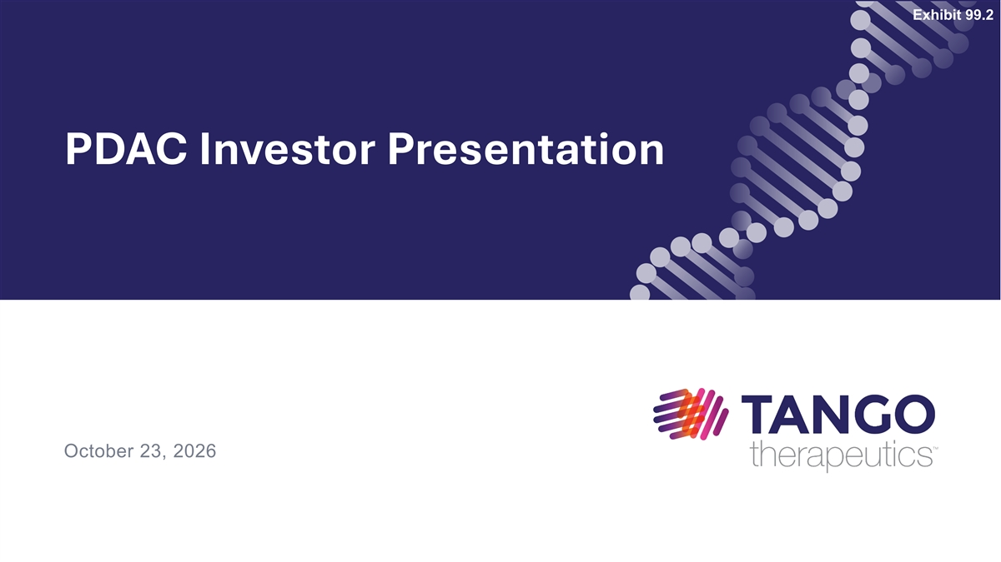
Exhibit 99.2 PDAC Investor Presentation October 23, 2026

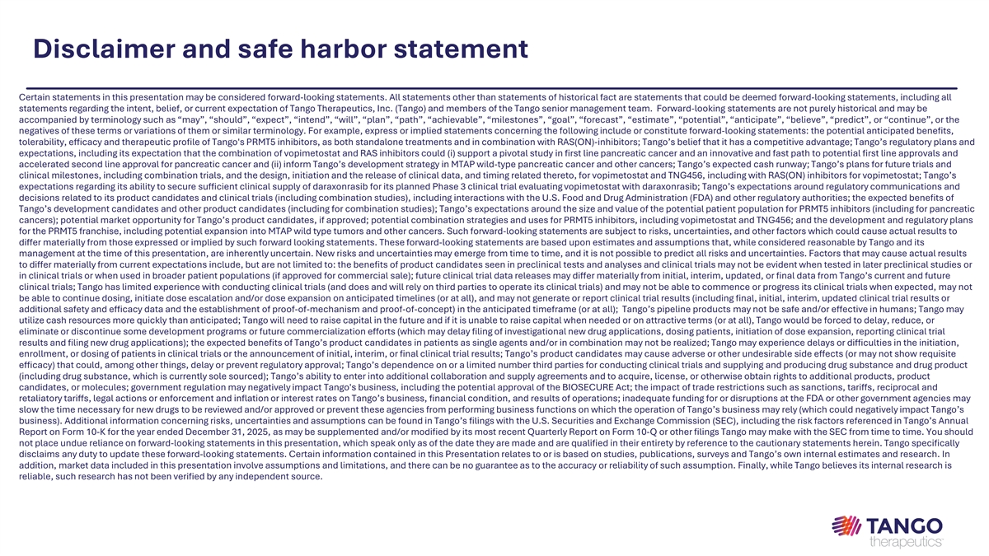
Disclaimer and safe harbor statement Certain statements in this presentation may be considered forward-looking statements. All statements other than statements of historical fact are statements that could be deemed forward-looking statements, including all statements regarding the intent, belief, or current expectation of Tango Therapeutics, Inc. (Tango) and members of the Tango senior management team. Forward-looking statements are not purely historical and may be accompanied by terminology such as “may”, “should”, “expect”, “intend”, “will”, “plan”, “path”, “achievable”, “milestones”, “goal”, “forecast”, “estimate”, “potential”, “anticipate”, “believe”, “predict”, or “continue”, or the negatives of these terms or variations of them or similar terminology. For example, express or implied statements concerning the following include or constitute forward-looking statements: the potential anticipated benefits, tolerability, efficacy and therapeutic profile of Tango's PRMT5 inhibitors, as both standalone treatments and in combination with RAS(ON)-inhibitors; Tango’s belief that it has a competitive advantage; Tango’s regulatory plans and expectations, including its expectation that the combination of vopimetostat and RAS inhibitors could (i) support a pivotal study in first line pancreatic cancer and an innovative and fast path to potential first line approvals and accelerated second line approval for pancreatic cancer and (ii) inform Tango’s development strategy in MTAP wild-type pancreatic cancer and other cancers; Tango’s expected cash runway; Tango’s plans for future trials and clinical milestones, including combination trials, and the design, initiation and the release of clinical data, and timing related thereto, for vopimetostat and TNG456, including with RAS(ON) inhibitors for vopimetostat; Tango’s expectations regarding its ability to secure sufficient clinical supply of daraxonrasib for its planned Phase 3 clinical trial evaluating vopimetostat with daraxonrasib; Tango’s expectations around regulatory communications and decisions related to its product candidates and clinical trials (including combination studies), including interactions with the U.S. Food and Drug Administration (FDA) and other regulatory authorities; the expected benefits of Tango’s development candidates and other product candidates (including for combination studies); Tango’s expectations around the size and value of the potential patient population for PRMT5 inhibitors (including for pancreatic cancers); potential market opportunity for Tango’s product candidates, if approved; potential combination strategies and uses for PRMT5 inhibitors, including vopimetostat and TNG456; and the development and regulatory plans for the PRMT5 franchise, including potential expansion into MTAP wild type tumors and other cancers. Such forward-looking statements are subject to risks, uncertainties, and other factors which could cause actual results to differ materially from those expressed or implied by such forward looking statements. These forward-looking statements are based upon estimates and assumptions that, while considered reasonable by Tango and its management at the time of this presentation, are inherently uncertain. New risks and uncertainties may emerge from time to time, and it is not possible to predict all risks and uncertainties. Factors that may cause actual results to differ materially from current expectations include, but are not limited to: the benefits of product candidates seen in preclinical tests and analyses and clinical trials may not be evident when tested in later preclinical studies or in clinical trials or when used in broader patient populations (if approved for commercial sale); future clinical trial data releases may differ materially from initial, interim, updated, or final data from Tango’s current and future clinical trials; Tango has limited experience with conducting clinical trials (and does and will rely on third parties to operate its clinical trials) and may not be able to commence or progress its clinical trials when expected, may not be able to continue dosing, initiate dose escalation and/or dose expansion on anticipated timelines (or at all), and may not generate or report clinical trial results (including final, initial, interim, updated clinical trial results or additional safety and efficacy data and the establishment of proof-of-mechanism and proof-of-concept) in the anticipated timeframe (or at all); Tango’s pipeline products may not be safe and/or effective in humans; Tango may utilize cash resources more quickly than anticipated; Tango will need to raise capital in the future and if it is unable to raise capital when needed or on attractive terms (or at all), Tango would be forced to delay, reduce, or eliminate or discontinue some development programs or future commercialization efforts (which may delay filing of investigational new drug applications, dosing patients, initiation of dose expansion, reporting clinical trial results and filing new drug applications); the expected benefits of Tango’s product candidates in patients as single agents and/or in combination may not be realized; Tango may experience delays or difficulties in the initiation, enrollment, or dosing of patients in clinical trials or the announcement of initial, interim, or final clinical trial results; Tango’s product candidates may cause adverse or other undesirable side effects (or may not show requisite efficacy) that could, among other things, delay or prevent regulatory approval; Tango’s dependence on or a limited number third parties for conducting clinical trials and supplying and producing drug substance and drug product (including drug substance, which is currently sole sourced); Tango’s ability to enter into additional collaboration and supply agreements and to acquire, license, or otherwise obtain rights to additional products, product candidates, or molecules; government regulation may negatively impact Tango's business, including the potential approval of the BIOSECURE Act; the impact of trade restrictions such as sanctions, tariffs, reciprocal and retaliatory tariffs, legal actions or enforcement and inflation or interest rates on Tango’s business, financial condition, and results of operations; inadequate funding for or disruptions at the FDA or other government agencies may slow the time necessary for new drugs to be reviewed and/or approved or prevent these agencies from performing business functions on which the operation of Tango’s business may rely (which could negatively impact Tango’s business). Additional information concerning risks, uncertainties and assumptions can be found in Tango’s filings with the U.S. Securities and Exchange Commission (SEC), including the risk factors referenced in Tango’s Annual Report on Form 10-K for the year ended December 31, 2025, as may be supplemented and/or modified by its most recent Quarterly Report on Form 10-Q or other filings Tango may make with the SEC from time to time. You should not place undue reliance on forward-looking statements in this presentation, which speak only as of the date they are made and are qualified in their entirety by reference to the cautionary statements herein. Tango specifically disclaims any duty to update these forward-looking statements. Certain information contained in this Presentation relates to or is based on studies, publications, surveys and Tango’s own internal estimates and research. In addition, market data included in this presentation involve assumptions and limitations, and there can be no guarantee as to the accuracy or reliability of such assumption. Finally, while Tango believes its internal research is reliable, such research has not been verified by any independent source.

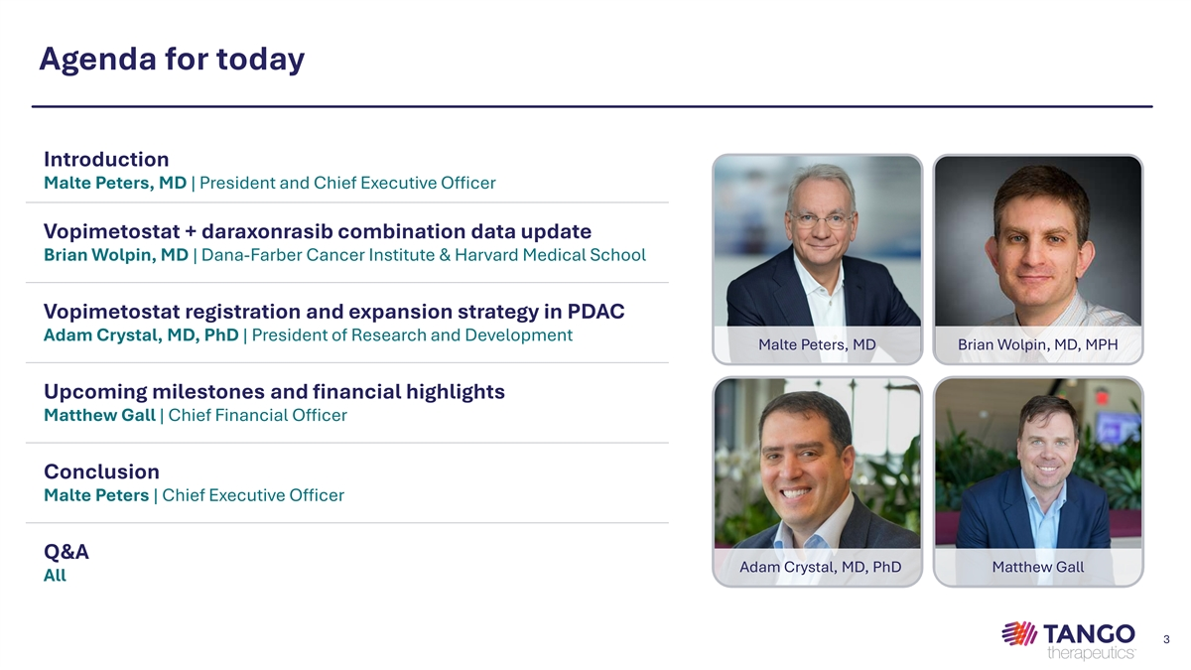
Agenda for today Introduction Malte Peters, MD | President and Chief Executive Officer Vopimetostat + daraxonrasib combination data update Brian Wolpin, MD | Dana-Farber Cancer Institute & Harvard Medical School Vopimetostat registration and expansion strategy in PDAC Adam Crystal, MD, PhD | President of Research and Development Malte Peters, MD Brian Wolpin, MD, MPH Upcoming milestones and financial highlights Matthew Gall | Chief Financial Officer Conclusion Malte Peters | Chief Executive Officer Q&A Adam Crystal, MD, PhD Matthew Gall All 3

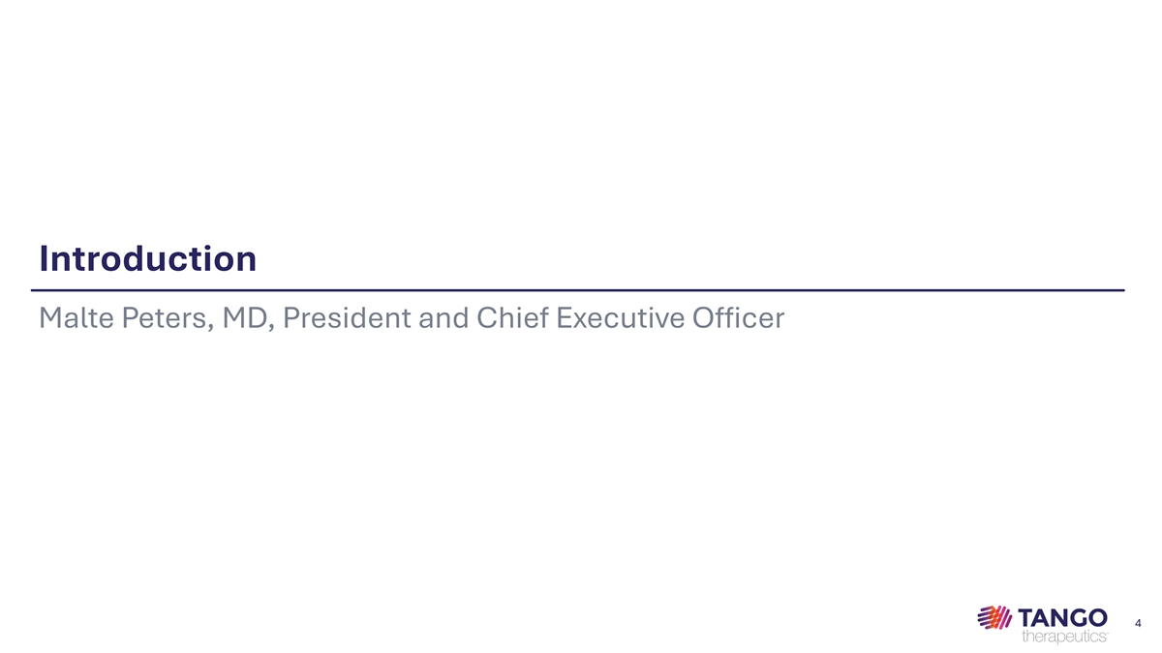
Introduction Malte Peters, MD, President and Chief Executive Officer 4

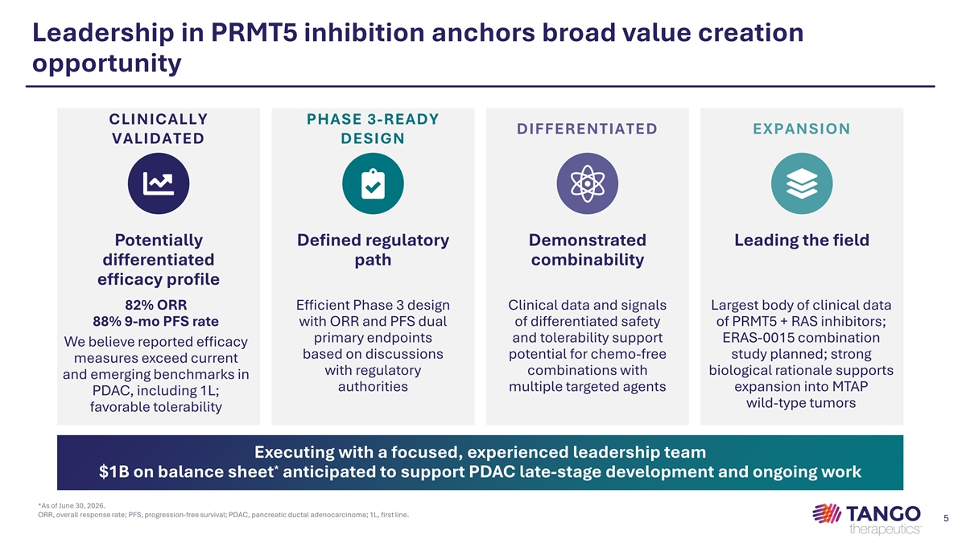
Leadership in PRMT5 inhibition anchors broad value creation opportunity CLINICALLY PHASE 3-READY DIFFERENTIATED EXPANSION VALIDATED DESIGN Potentially Defined regulatory Demonstrated Leading the field differentiated path combinability efficacy profile 82% ORR Efficient Phase 3 design Clinical data and signals Largest body of clinical data 88% 9-mo PFS rate with ORR and PFS dual of differentiated safety of PRMT5 + RAS inhibitors; primary endpoints and tolerability support ERAS-0015 combination We believe reported efficacy based on discussions potential for chemo-free study planned; strong measures exceed current with regulatory combinations with biological rationale supports and emerging benchmarks in authorities multiple targeted agents expansion into MTAP PDAC, including 1L; wild-type tumors favorable tolerability Executing with a focused, experienced leadership team * $1B on balance sheet anticipated to support PDAC late-stage development and ongoing work *As of June 30, 2026. ORR, overall response rate; PFS, progression-free survival; PDAC, pancreatic ductal adenocarcinoma; 1L, first line. 5

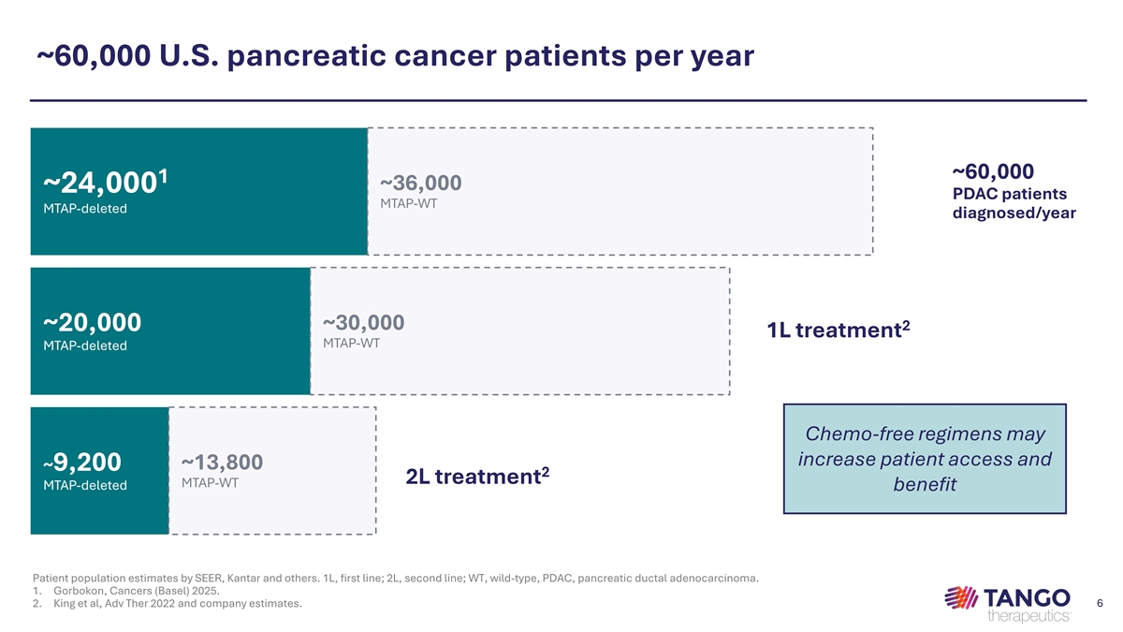
~60,000 U.S. pancreatic cancer patients per year ~60,000 1 ~36,000 ~24,000 PDAC patients MTAP-WT MTAP-deleted diagnosed/year ~30,000 2 ~20,000 1L treatment MTAP-WT MTAP-deleted Chemo-free regimens may increase patient access and ~13,800 ~9,200 2 2L treatment MTAP-WT MTAP-deleted benefit Patient population estimates by SEER, Kantar and others. 1L, first line; 2L, second line; WT, wild-type, PDAC, pancreatic ductal adenocarcinoma. 1. Gorbokon, Cancers (Basel) 2025. 2. King et al, Adv Ther 2022 and company estimates. 6

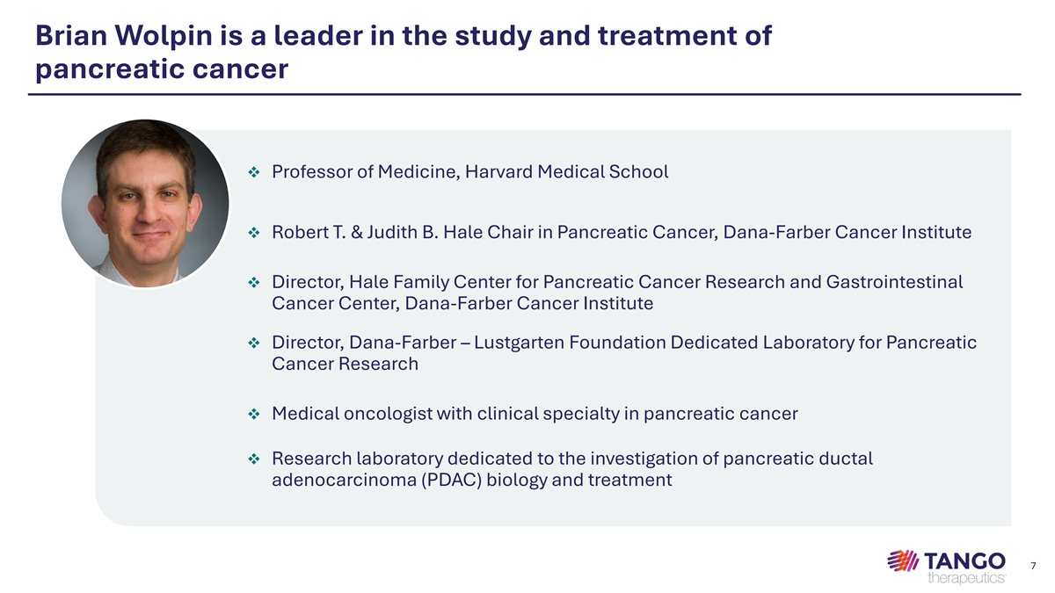
Brian Wolpin is a leader in the study and treatment of pancreatic cancer v Professor of Medicine, Harvard Medical School v Robert T. & Judith B. Hale Chair in Pancreatic Cancer, Dana-Farber Cancer Institute v Director, Hale Family Center for Pancreatic Cancer Research and Gastrointestinal Cancer Center, Dana-Farber Cancer Institute v Director, Dana-Farber – Lustgarten Foundation Dedicated Laboratory for Pancreatic Cancer Research v Medical oncologist with clinical specialty in pancreatic cancer v Research laboratory dedicated to the investigation of pancreatic ductal adenocarcinoma (PDAC) biology and treatment 7

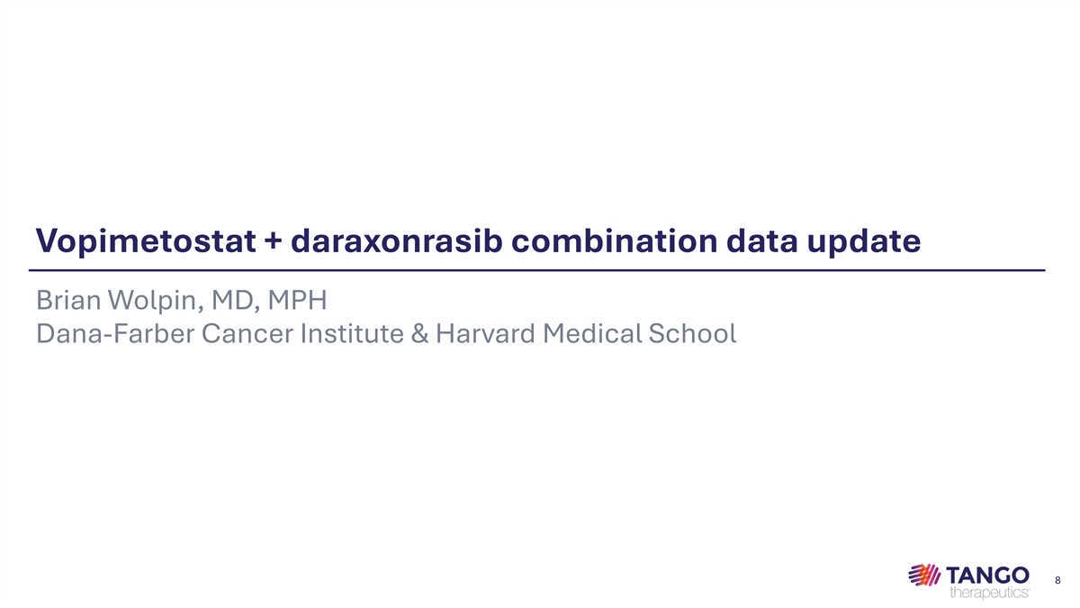
Vopimetostat + daraxonrasib combination data update Brian Wolpin, MD, MPH Dana-Farber Cancer Institute & Harvard Medical School 8

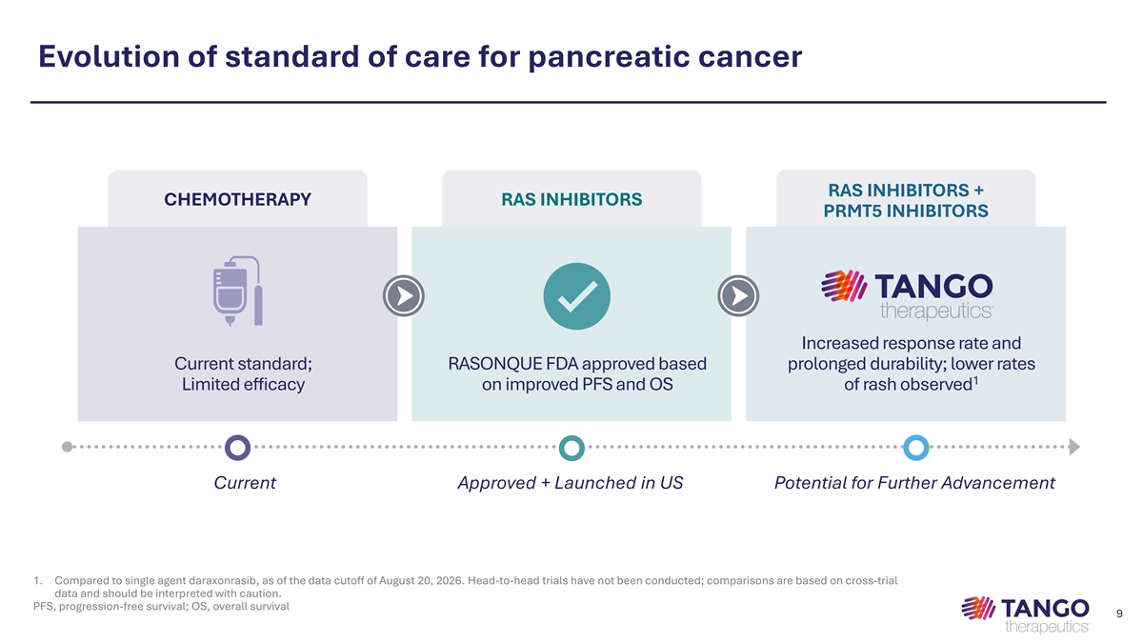
Evolution of standard of care for pancreatic cancer RAS INHIBITORS + CHEMOTHERAPY RAS INHIBITORS PRMT5 INHIBITORS Increased response rate and Current standard; RASONQUE FDA approved based prolonged durability; lower rates 1 Limited efficacy on improved PFS and OS of rash observed Current Approved + Launched in US Potential for Further Advancement 1. Compared to single agent daraxonrasib, as of the data cutoff of August 20, 2026. Head-to-head trials have not been conducted; comparisons are based on cross-trial data and should be interpreted with caution. PFS, progression-free survival; OS, overall survival 9

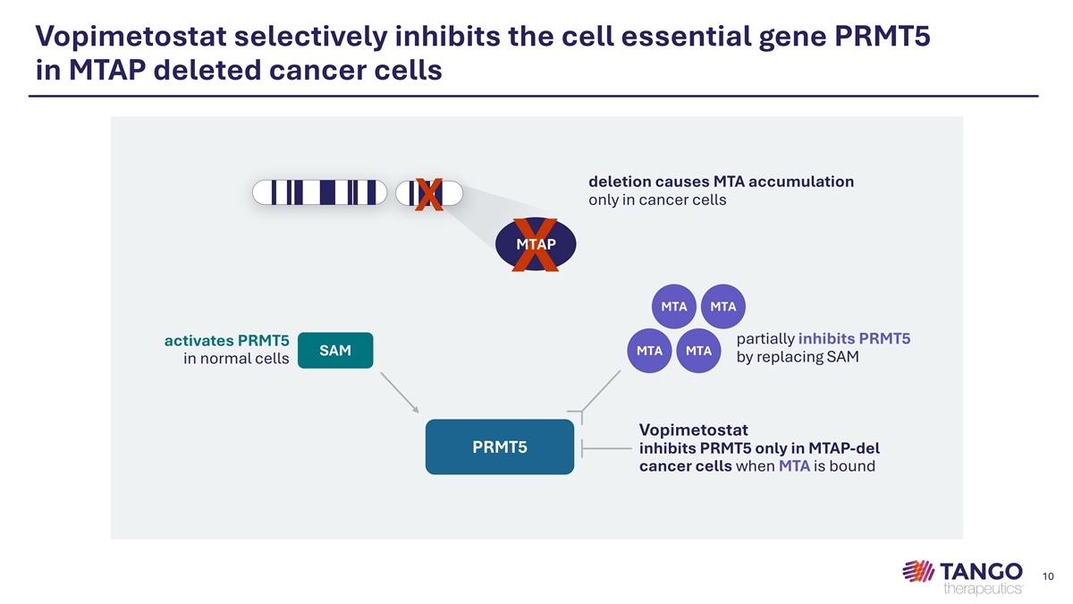
Vopimetostat selectively inhibits the cell essential gene PRMT5 in MTAP deleted cancer cells deletion causes MTA accumulation only in cancer cells X MTAP X MTA MTA partially inhibits PRMT5 activates PRMT5 SAM MTA MTA by replacing SAM in normal cells Vopimetostat PRMT5 inhibits PRMT5 only in MTAP-del cancer cells when MTA is bound 10

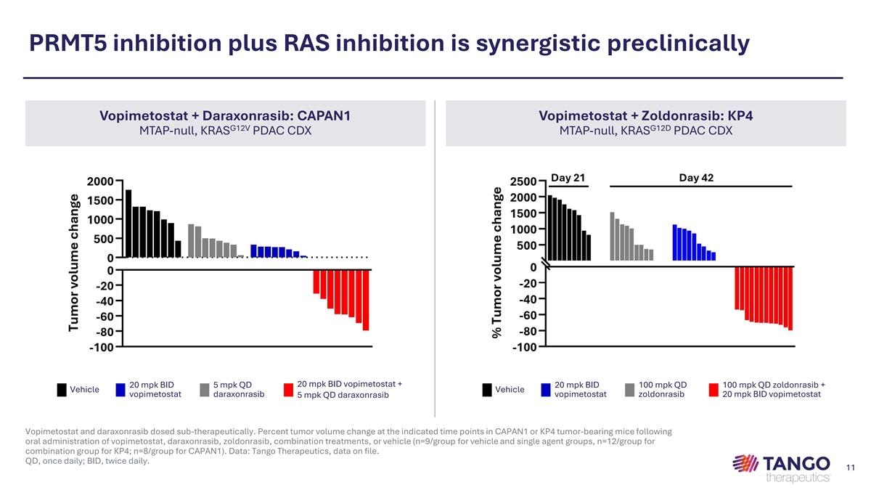
PRMT5 inhibition plus RAS inhibition is synergistic preclinically Vopimetostat + Daraxonrasib: CAPAN1 Vopimetostat + Zoldonrasib: KP4 G12V G12D MTAP-null, KRAS PDAC CDX MTAP-null, KRAS PDAC CDX 20 mpk BID vopimetostat + 20 mpk BID 5 mpk QD 20 mpk BID 100 mpk QD 100 mpk QD zoldonrasib + Vehicle Vehicle vopimetostat daraxonrasib vopimetostat zoldonrasib 20 mpk BID vopimetostat 5 mpk QD daraxonrasib Vopimetostat and daraxonrasib dosed sub-therapeutically. Percent tumor volume change at the indicated time points in CAPAN1 or KP4 tumor-bearing mice following oral administration of vopimetostat, daraxonrasib, zoldonrasib, combination treatments, or vehicle (n=9/group for vehicle and single agent groups, n=12/group for combination group for KP4; n=8/group for CAPAN1). Data: Tango Therapeutics, data on file. 11 QD, once daily; BID, twice daily. 11

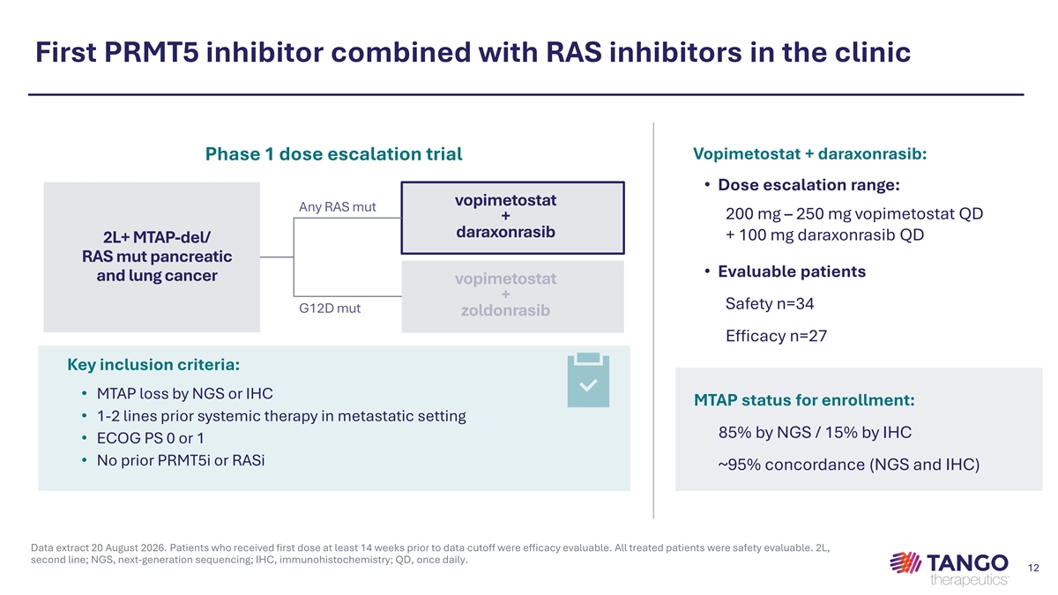
First PRMT5 inhibitor combined with RAS inhibitors in the clinic Vopimetostat + daraxonrasib: Phase 1 dose escalation trial • Dose escalation range: vopimetostat Any RAS mut 200 mg – 250 mg vopimetostat QD + daraxonrasib + 100 mg daraxonrasib QD 2L+ MTAP-del/ RAS mut pancreatic • Evaluable patients and lung cancer vopimetostat + Safety n=34 G12D mut zoldonrasib Efficacy n=27 Key inclusion criteria: • MTAP loss by NGS or IHC MTAP status for enrollment: • 1-2 lines prior systemic therapy in metastatic setting 85% by NGS / 15% by IHC • ECOG PS 0 or 1 • No prior PRMT5i or RASi ~95% concordance (NGS and IHC) Data extract 20 August 2026. Patients who received first dose at least 14 weeks prior to data cutoff were efficacy evaluable. All treated patients were safety evaluable. 2L, second line; NGS, next-generation sequencing; IHC, immunohistochemistry; QD, once daily. 12

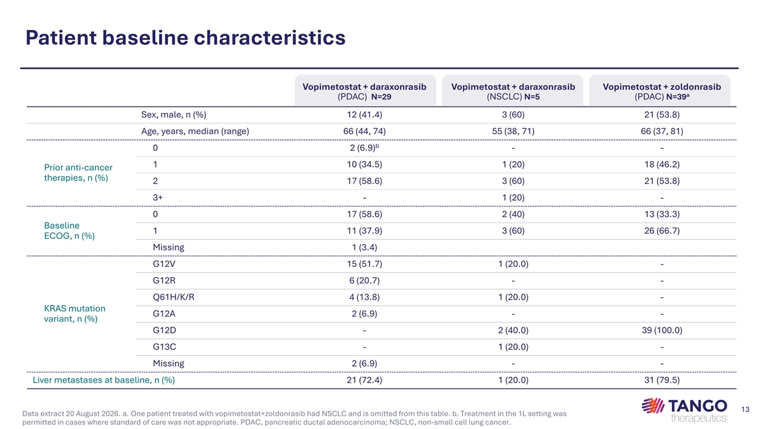
Patient baseline characteristics Vopimetostat + daraxonrasib Vopimetostat + daraxonrasib Vopimetostat + zoldonrasib a (PDAC) N=29 (NSCLC) N=5 (PDAC) N=39 Sex, male, n (%) 12 (41.4) 3 (60) 21 (53.8) Age, years, median (range) 66 (44, 74) 55 (38, 71) 66 (37, 81) b 0 2 (6.9) - - 1 10 (34.5) 1 (20) 18 (46.2) Prior anti-cancer therapies, n (%) 2 17 (58.6) 3 (60) 21 (53.8) 3+ - 1 (20) - 0 17 (58.6) 2 (40) 13 (33.3) Baseline 1 11 (37.9) 3 (60) 26 (66.7) ECOG, n (%) Missing 1 (3.4) G12V 15 (51.7) 1 (20.0) - G12R 6 (20.7) - - Q61H/K/R 4 (13.8) 1 (20.0) - KRAS mutation G12A 2 (6.9) - - variant, n (%) G12D - 2 (40.0) 39 (100.0) G13C - 1 (20.0) - Missing 2 (6.9) - - Liver metastases at baseline, n (%) 21 (72.4) 1 (20.0) 31 (79.5) 13 Data extract 20 August 2026. a. One patient treated with vopimetostat+zoldonrasib had NSCLC and is omitted from this table. b. Treatment in the 1L setting was permitted in cases where standard of care was not appropriate. PDAC, pancreatic ductal adenocarcinoma; NSCLC, non-small cell lung cancer.

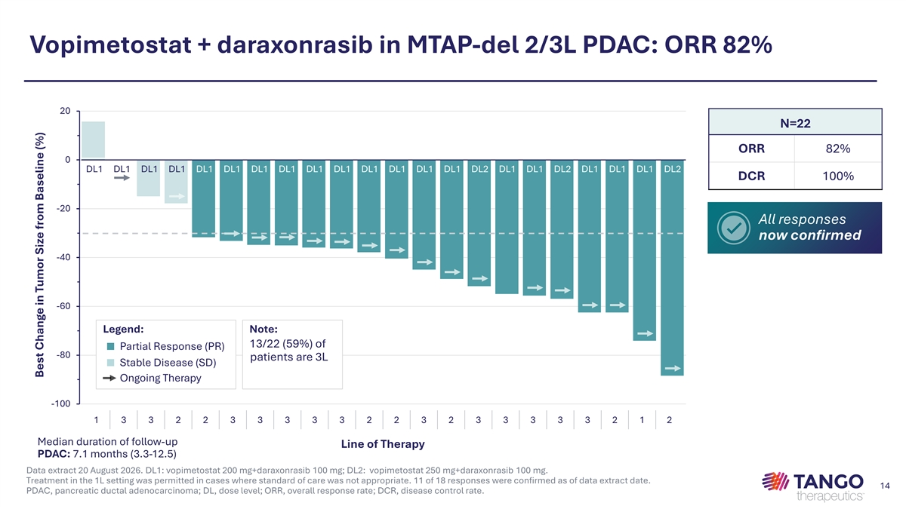
Vopimetostat + daraxonrasib in MTAP-del 2/3L PDAC: ORR 82% 20 N=22 ORR 82% 0 DL1 DL1 DL1 DL1 DL1 DL1 DL1 DL1 DL1 DL1 DL1 DL1 DL1 DL1 DL2 DL1 DL1 DL2 DL1 DL1 DL1 DL2 DCR 100% -20 All responses now confirmed -40 -60 Legend: Note: 13/22 (59%) of ■ Partial Response (PR) -80 patients are 3L ■ Stable Disease (SD) Ongoing Therapy -100 1 3 3 2 2 3 3 3 3 3 2 2 3 2 3 3 3 3 3 2 1 2 Median duration of follow-up Line of Therapy PDAC: 7.1 months (3.3-12.5) Data extract 20 August 2026. DL1: vopimetostat 200 mg+daraxonrasib 100 mg; DL2: vopimetostat 250 mg+daraxonrasib 100 mg. Treatment in the 1L setting was permitted in cases where standard of care was not appropriate. 11 of 18 responses were confirmed as of data extract date. 14 PDAC, pancreatic ductal adenocarcinoma; DL, dose level; ORR, overall response rate; DCR, disease control rate. Best Change in Tumor Size from Baseline (%)

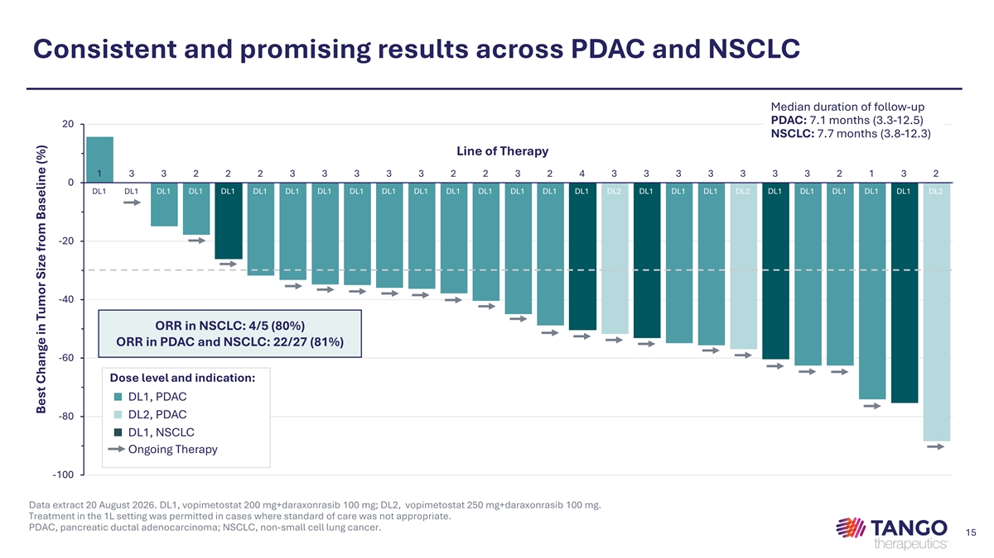
Consistent and promising results across PDAC and NSCLC Median duration of follow-up PDAC: 7.1 months (3.3-12.5) 20 NSCLC: 7.7 months (3.8-12.3) Line of Therapy 1 3 3 2 2 2 3 3 3 3 3 2 2 3 2 4 3 3 3 3 3 3 3 2 1 3 2 0 DL1 DL1 DL1 DL1 DL1 DL1 DL1 DL1 DL1 DL1 DL1 DL1 DL1 DL1 DL1 DL1 DL2 DL1 DL1 DL1 DL2 DL1 DL1 DL1 DL1 DL1 DL2 -20 -40 ORR in NSCLC: 4/5 (80%) ORR in PDAC and NSCLC: 22/27 (81%) -60 Dose level and indication: ■ DL1, PDAC ■ DL2, PDAC -80 ■ DL1, NSCLC Ongoing Therapy -100 Data extract 20 August 2026. DL1, vopimetostat 200 mg+daraxonrasib 100 mg; DL2, vopimetostat 250 mg+daraxonrasib 100 mg. Treatment in the 1L setting was permitted in cases where standard of care was not appropriate. PDAC, pancreatic ductal adenocarcinoma; NSCLC, non-small cell lung cancer. 15 Best Change in Tumor Size from Baseline (%)

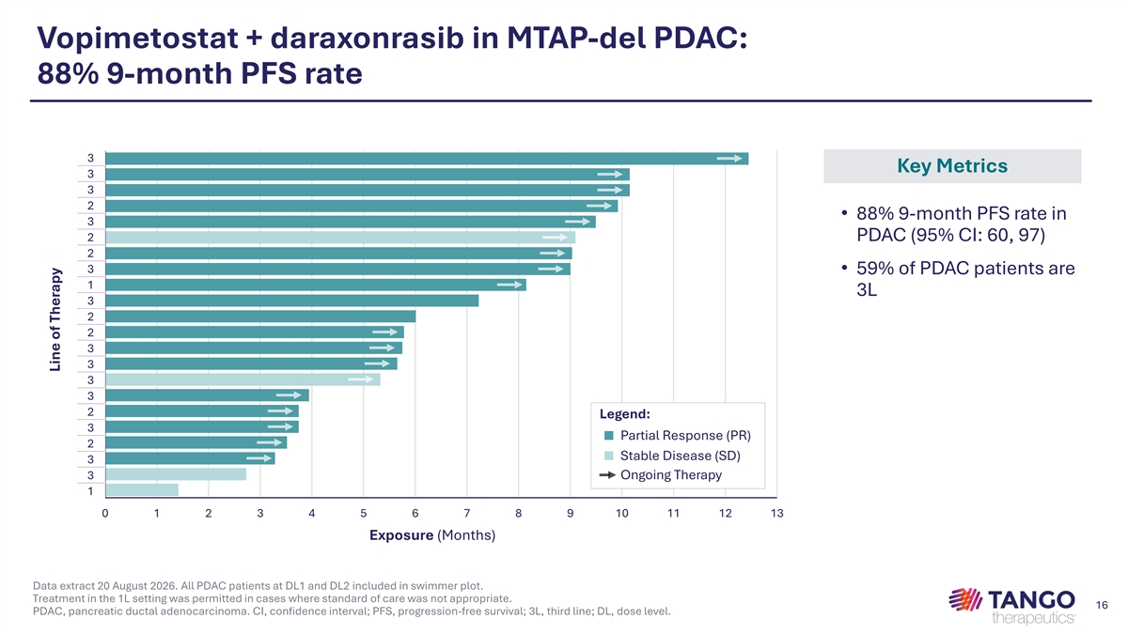
Vopimetostat + daraxonrasib in MTAP-del PDAC: 88% 9-month PFS rate 3 Key Metrics 3 3 2 • 88% 9-month PFS rate in 3 2 PDAC (95% CI: 60, 97) 2 3 • 59% of PDAC patients are 1 3L 3 2 2 3 3 3 3 2 Legend: 3 ■ Partial Response (PR) 2 ■ Stable Disease (SD) 3 3 Ongoing Therapy 1 0 1 2 3 4 5 6 7 8 9 10 11 12 13 Exposure (Months) Data extract 20 August 2026. All PDAC patients at DL1 and DL2 included in swimmer plot. Treatment in the 1L setting was permitted in cases where standard of care was not appropriate. 16 PDAC, pancreatic ductal adenocarcinoma. CI, confidence interval; PFS, progression-free survival; 3L, third line; DL, dose level. Line of Therapy

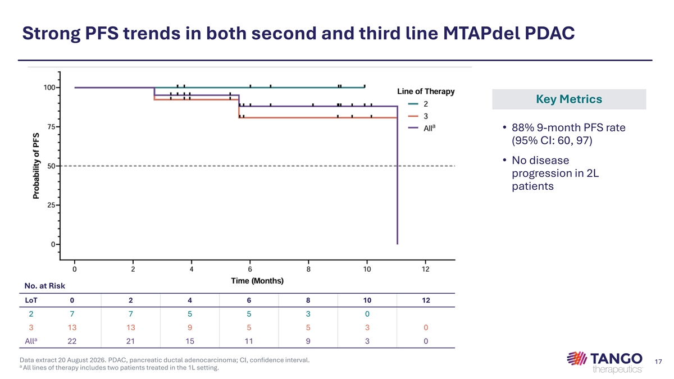
Strong PFS trends in both second and third line MTAPdel PDAC Key Metrics • 88% 9-month PFS rate (95% CI: 60, 97) • No disease progression in 2L patients No. at Risk LoT 0 2 4 6 8 10 12 2 7 7 5 5 3 0 3 13 13 9 5 5 3 0 a All 22 21 15 11 9 3 0 Data extract 20 August 2026. PDAC, pancreatic ductal adenocarcinoma; CI, confidence interval. 17 a All lines of therapy includes two patients treated in the 1L setting.

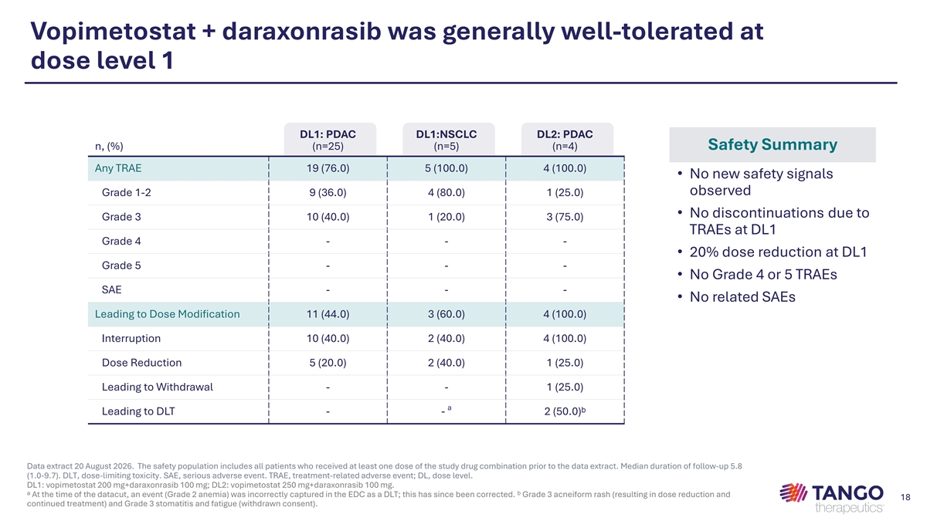
Vopimetostat + daraxonrasib was generally well-tolerated at dose level 1 DL1: PDAC DL1:NSCLC DL2: PDAC n, (%) (n=25) (n=5) (n=4) Safety Summary Any TRAE 19 (76.0) 5 (100.0) 4 (100.0) • No new safety signals observed Grade 1-2 9 (36.0) 4 (80.0) 1 (25.0) • No discontinuations due to Grade 3 10 (40.0) 1 (20.0) 3 (75.0) TRAEs at DL1 Grade 4 - - - • 20% dose reduction at DL1 Grade 5 - - - • No Grade 4 or 5 TRAEs SAE - - - • No related SAEs Leading to Dose Modification 11 (44.0) 3 (60.0) 4 (100.0) Interruption 10 (40.0) 2 (40.0) 4 (100.0) Dose Reduction 5 (20.0) 2 (40.0) 1 (25.0) Leading to Withdrawal - - 1 (25.0) a Leading to DLT - - 2 (50.0)ᵇ Data extract 20 August 2026. The safety population includes all patients who received at least one dose of the study drug combination prior to the data extract. Median duration of follow-up 5.8 (1.0-9.7). DLT, dose-limiting toxicity. SAE, serious adverse event. TRAE, treatment-related adverse event; DL, dose level. DL1: vopimetostat 200 mg+daraxonrasib 100 mg; DL2: vopimetostat 250 mg+daraxonrasib 100 mg. ᵃ At the time of the datacut, an event (Grade 2 anemia) was incorrectly captured in the EDC as a DLT; this has since been corrected. ᵇ Grade 3 acneiform rash (resulting in dose reduction and 18 continued treatment) and Grade 3 stomatitis and fatigue (withdrawn consent).

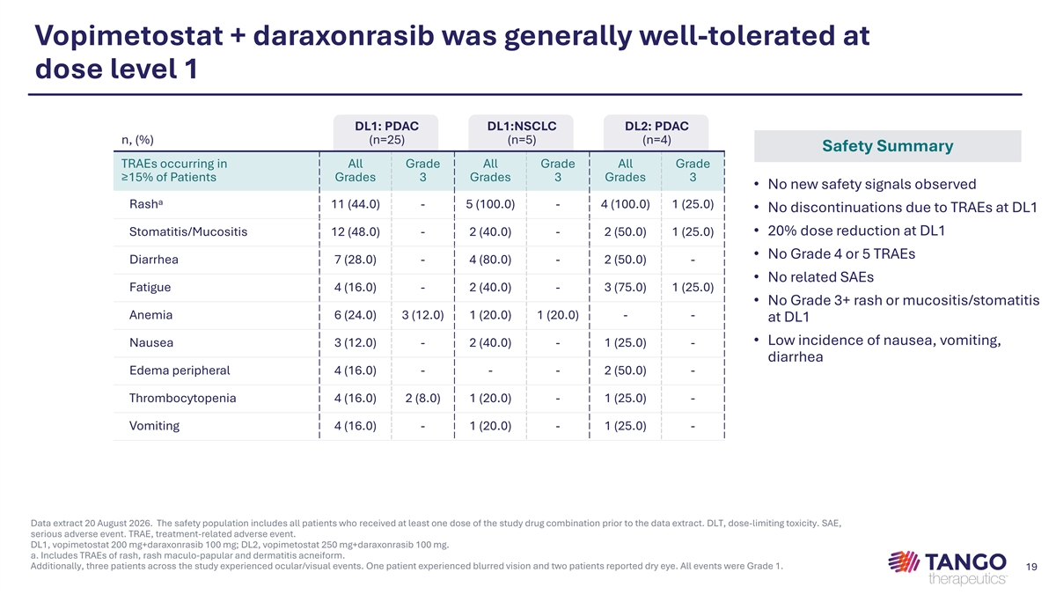
Vopimetostat + daraxonrasib was generally well-tolerated at dose level 1 DL1: PDAC DL1:NSCLC DL2: PDAC n, (%) (n=25) (n=5) (n=4) Safety Summary TRAEs occurring in All Grade All Grade All Grade ≥15% of Patients Grades 3 Grades 3 Grades 3 • No new safety signals observed a Rash 11 (44.0) - 5 (100.0) - 4 (100.0) 1 (25.0) • No discontinuations due to TRAEs at DL1 • 20% dose reduction at DL1 Stomatitis/Mucositis 12 (48.0) - 2 (40.0) - 2 (50.0) 1 (25.0) • No Grade 4 or 5 TRAEs Diarrhea 7 (28.0) - 4 (80.0) - 2 (50.0) - • No related SAEs Fatigue 4 (16.0) - 2 (40.0) - 3 (75.0) 1 (25.0) • No Grade 3+ rash or mucositis/stomatitis Anemia 6 (24.0) 3 (12.0) 1 (20.0) 1 (20.0) - - at DL1 • Low incidence of nausea, vomiting, Nausea 3 (12.0) - 2 (40.0) - 1 (25.0) - diarrhea Edema peripheral 4 (16.0) - - - 2 (50.0) - Thrombocytopenia 4 (16.0) 2 (8.0) 1 (20.0) - 1 (25.0) - Vomiting 4 (16.0) - 1 (20.0) - 1 (25.0) - Data extract 20 August 2026. The safety population includes all patients who received at least one dose of the study drug combination prior to the data extract. DLT, dose-limiting toxicity. SAE, serious adverse event. TRAE, treatment-related adverse event. DL1, vopimetostat 200 mg+daraxonrasib 100 mg; DL2, vopimetostat 250 mg+daraxonrasib 100 mg. a. Includes TRAEs of rash, rash maculo-papular and dermatitis acneiform. Additionally, three patients across the study experienced ocular/visual events. One patient experienced blurred vision and two patients reported dry eye. All events were Grade 1. 19

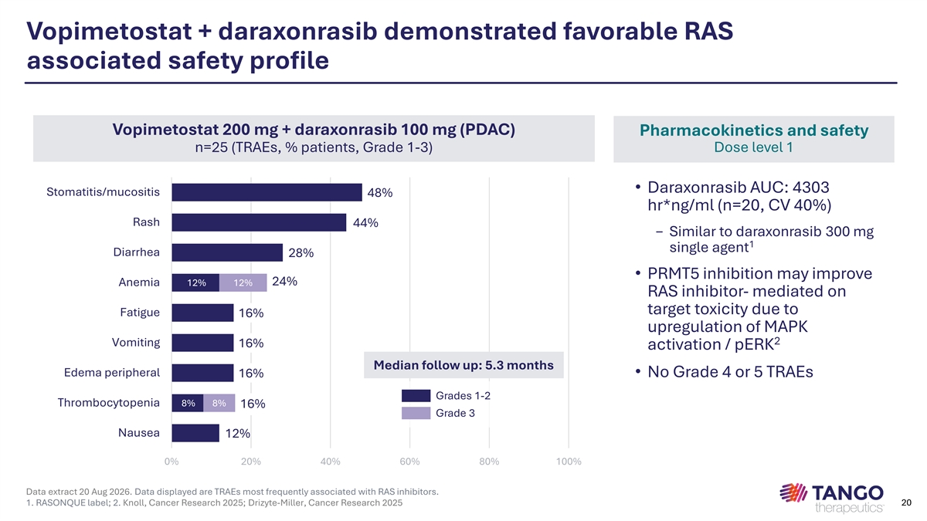
Vopimetostat + daraxonrasib demonstrated favorable RAS associated safety profile Vopimetostat 200 mg + daraxonrasib 100 mg (PDAC) Pharmacokinetics and safety n=25 (TRAEs, % patients, Grade 1-3) Dose level 1 • Daraxonrasib AUC: 4303 Stomatitis/mucositis 48% hr*ng/ml (n=20, CV 40%) Rash 44% − Similar to daraxonrasib 300 mg 1 single agent Diarrhea 28% • PRMT5 inhibition may improve 24% Anemia 12% 12% RAS inhibitor- mediated on target toxicity due to Fatigue 16% upregulation of MAPK 2 Vomiting 16% activation / pERK Median follow up: 5.3 months Edema peripheral 16% • No Grade 4 or 5 TRAEs Grades 1-2 Thrombocytopenia 8% 8% 16% Grade 3 Nausea 12% 0% 20% 40% 60% 80% 100% Data extract 20 Aug 2026. Data displayed are TRAEs most frequently associated with RAS inhibitors. 1. RASONQUE label; 2. Knoll, Cancer Research 2025; Drizyte-Miller, Cancer Research 2025 20

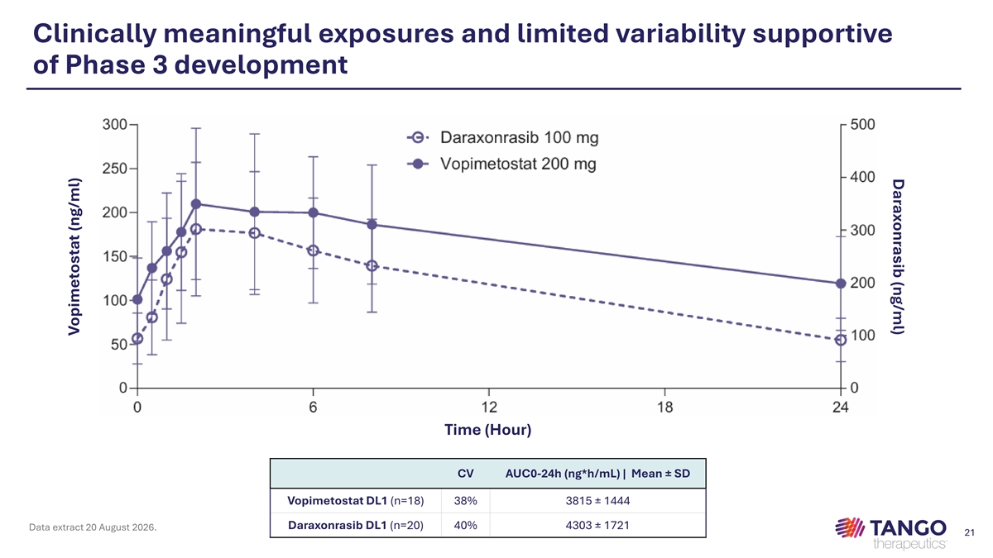
Daraxonrasib (ng/ml) Clinically meaningful exposures and limited variability supportive of Phase 3 development Time (Hour) CV AUC0-24h (ng*h/mL) | Mean ± SD Vopimetostat DL1 (n=18) 38% 3815 ± 1444 Daraxonrasib DL1 (n=20) 40% 4303 ± 1721 Data extract 20 August 2026. 21 Vopimetostat (ng/ml)

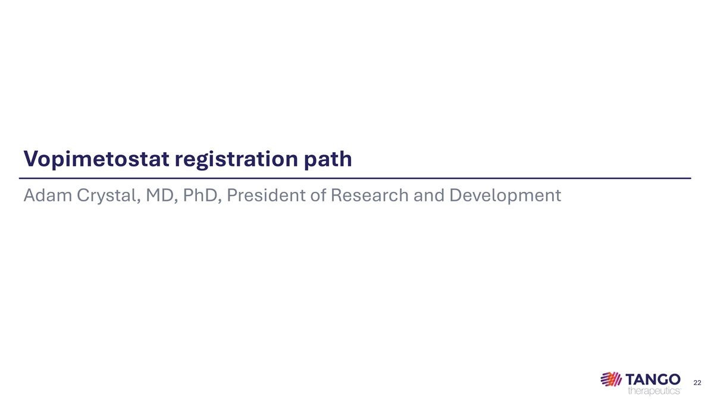
Vopimetostat registration path Adam Crystal, MD, PhD, President of Research and Development 22

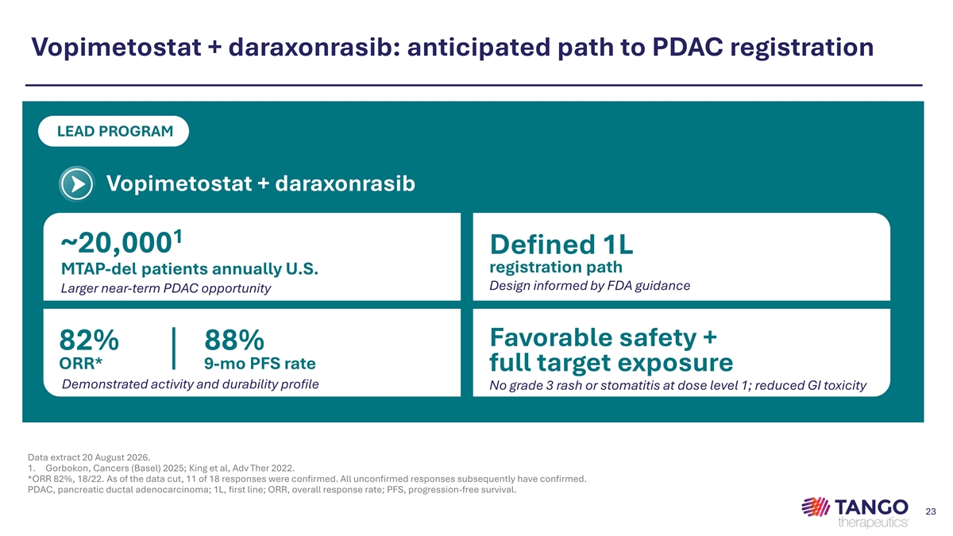
Vopimetostat + daraxonrasib: anticipated path to PDAC registration LEAD PROGRAM Vopimetostat + daraxonrasib 1 ~20,000 Defined 1L registration path MTAP-del patients annually U.S. Design informed by FDA guidance Larger near-term PDAC opportunity Favorable safety + 82% 88% ORR* 9-mo PFS rate full target exposure Demonstrated activity and durability profile No grade 3 rash or stomatitis at dose level 1; reduced GI toxicity Data extract 20 August 2026. 1. Gorbokon, Cancers (Basel) 2025; King et al, Adv Ther 2022. *ORR 82%, 18/22. As of the data cut, 11 of 18 responses were confirmed. All unconfirmed responses subsequently have confirmed. PDAC, pancreatic ductal adenocarcinoma; 1L, first line; ORR, overall response rate; PFS, progression-free survival. 23

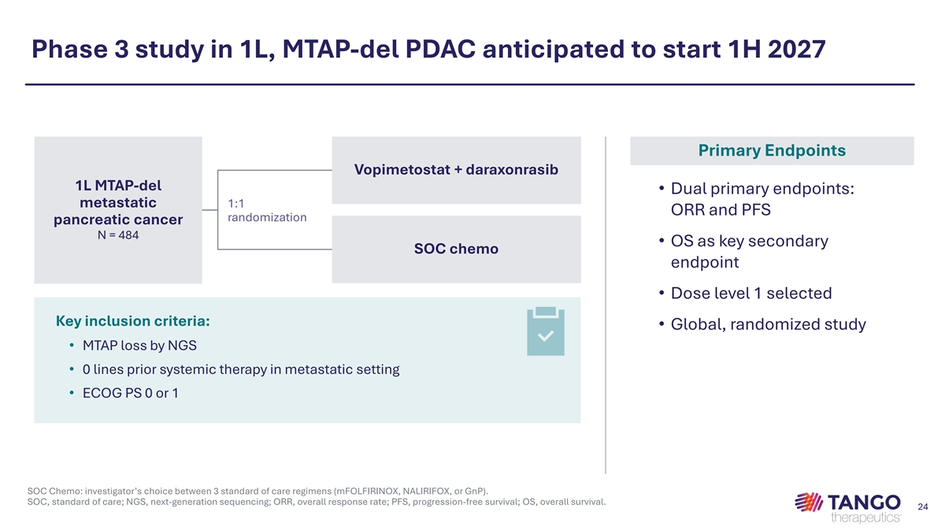
Phase 3 study in 1L, MTAP-del PDAC anticipated to start 1H 2027 Primary Endpoints Vopimetostat + daraxonrasib 1L MTAP-del • Dual primary endpoints: metastatic 1:1 ORR and PFS randomization pancreatic cancer N = 484 • OS as key secondary SOC chemo endpoint • Dose level 1 selected Key inclusion criteria: • Global, randomized study • MTAP loss by NGS • 0 lines prior systemic therapy in metastatic setting • ECOG PS 0 or 1 SOC Chemo: investigator’s choice between 3 standard of care regimens (mFOLFIRINOX, NALIRIFOX, or GnP). SOC, standard of care; NGS, next-generation sequencing; ORR, overall response rate; PFS, progression-free survival; OS, overall survival. 24

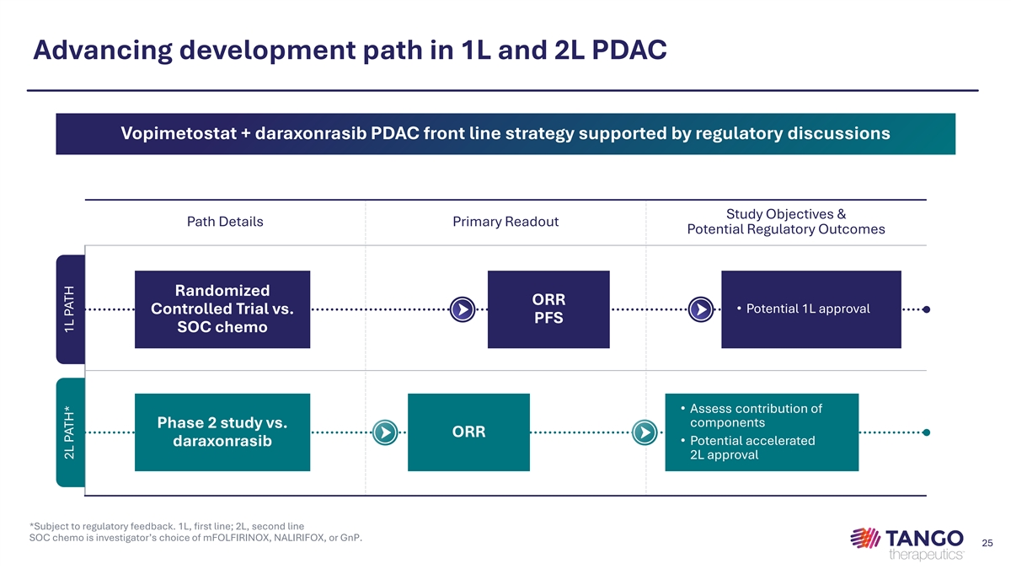
Advancing development path in 1L and 2L PDAC Vopimetostat + daraxonrasib PDAC front line strategy supported by regulatory discussions Study Objectives & Path Details Primary Readout Potential Regulatory Outcomes Randomized ORR • Potential 1L approval Controlled Trial vs. PFS SOC chemo • Assess contribution of components Phase 2 study vs. ORR • Potential accelerated daraxonrasib 2L approval *Subject to regulatory feedback. 1L, first line; 2L, second line SOC chemo is investigator’s choice of mFOLFIRINOX, NALIRIFOX, or GnP. 25 2L PATH* 1L PATH

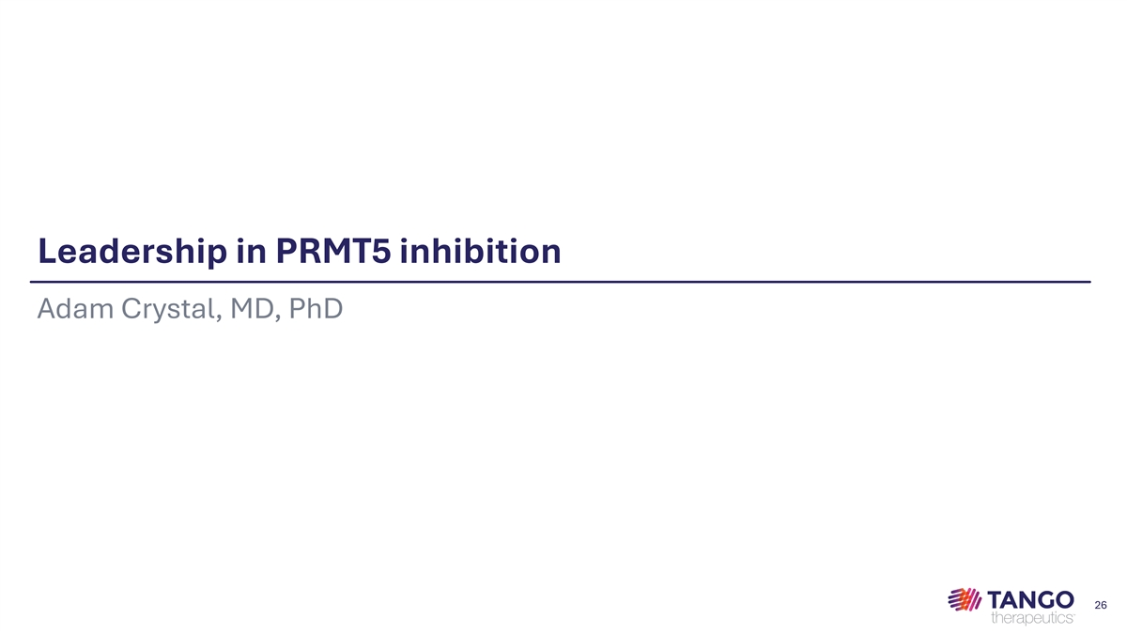
Leadership in PRMT5 inhibition Adam Crystal, MD, PhD 26

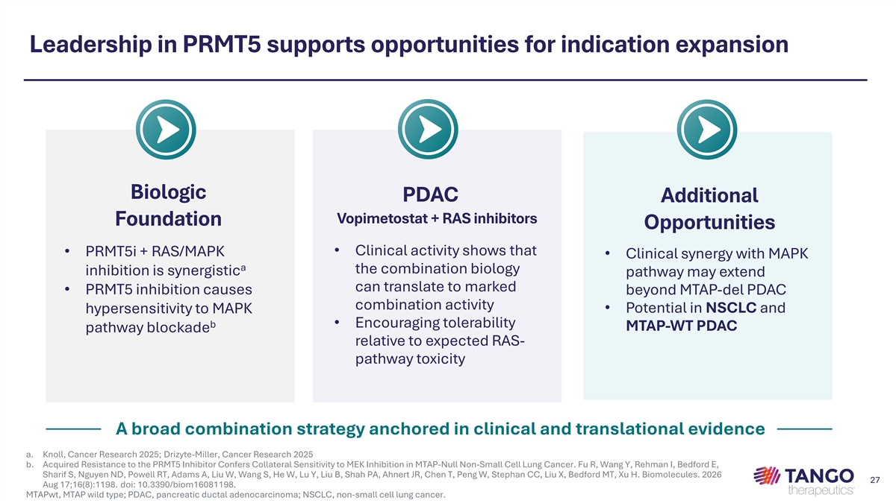
Leadership in PRMT5 supports opportunities for indication expansion Biologic PDAC Additional Vopimetostat + RAS inhibitors Foundation Opportunities • Clinical activity shows that • PRMT5i + RAS/MAPK • Clinical synergy with MAPK a the combination biology inhibition is synergistic pathway may extend can translate to marked • PRMT5 inhibition causes beyond MTAP-del PDAC combination activity • Potential in NSCLC and hypersensitivity to MAPK b • Encouraging tolerability MTAP-WT PDAC pathway blockade relative to expected RAS- pathway toxicity A broad combination strategy anchored in clinical and translational evidence a. Knoll, Cancer Research 2025; Drizyte-Miller, Cancer Research 2025 b. Acquired Resistance to the PRMT5 Inhibitor Confers Collateral Sensitivity to MEK Inhibition in MTAP-Null Non-Small Cell Lung Cancer. Fu R, Wang Y, Rehman I, Bedford E, Sharif S, Nguyen ND, Powell RT, Adams A, Liu W, Wang S, He W, Lu Y, Liu B, Shah PA, Ahnert JR, Chen T, Peng W, Stephan CC, Liu X, Bedford MT, Xu H. Biomolecules. 2026 27 Aug 17;16(8):1198. doi: 10.3390/biom16081198. MTAPwt, MTAP wild type; PDAC, pancreatic ductal adenocarcinoma; NSCLC, non-small cell lung cancer.

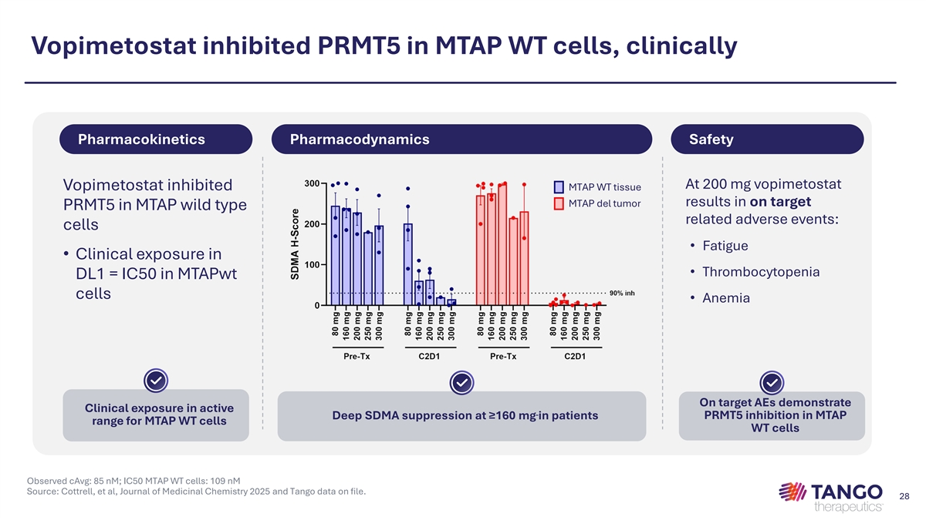
Vopimetostat inhibited PRMT5 in MTAP WT cells, clinically Pharmacokinetics Pharmacodynamics Safety At 200 mg vopimetostat Vopimetostat inhibited MTAP WT tissue results in on target MTAP del tumor PRMT5 in MTAP wild type related adverse events: cells • Fatigue • Clinical exposure in • Thrombocytopenia DL1 = IC50 in MTAPwt cells • Anemia On target AEs demonstrate Clinical exposure in active PRMT5 inhibition in MTAP Deep SDMA suppression at ≥160 mg in patients range for MTAP WT cells WT cells Observed cAvg: 85 nM; IC50 MTAP WT cells: 109 nM Source: Cottrell, et al, Journal of Medicinal Chemistry 2025 and Tango data on file. 28

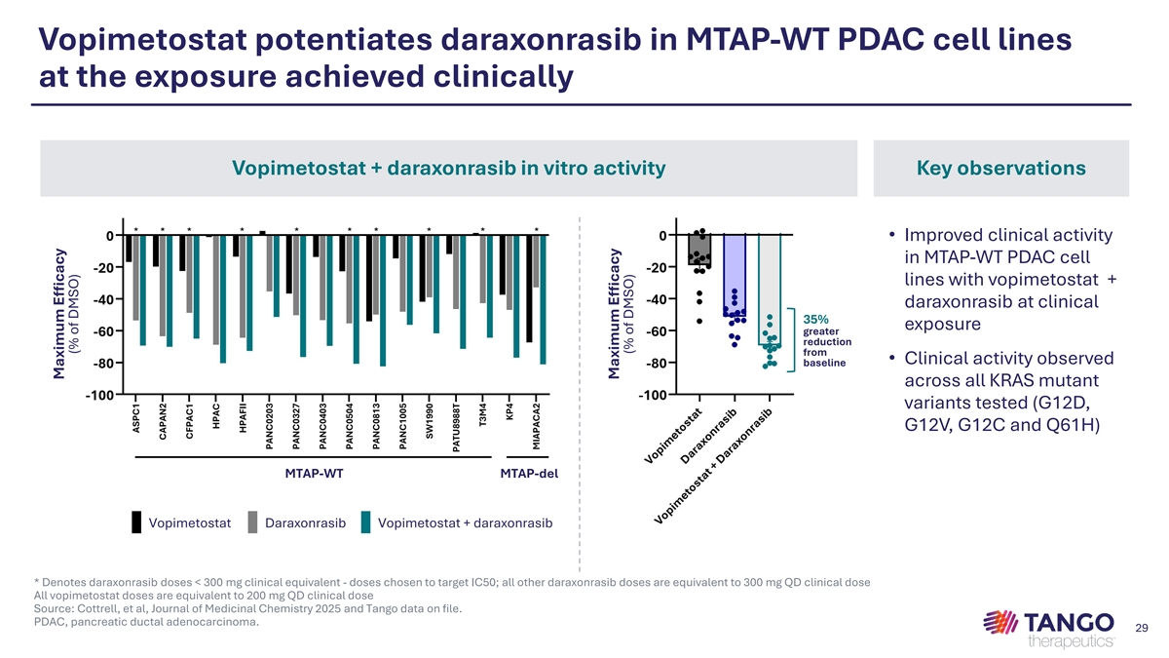
Vopimetostat potentiates daraxonrasib in MTAP-WT PDAC cell lines at the exposure achieved clinically Vopimetostat + daraxonrasib in vitro activity Key observations • Improved clinical activity in MTAP-WT PDAC cell lines with vopimetostat + daraxonrasib at clinical 35% exposure greater reduction from • Clinical activity observed baseline across all KRAS mutant variants tested (G12D, G12V, G12C and Q61H) MTAP-WT MTAP-del Vopimetostat Daraxonrasib Vopimetostat + daraxonrasib * Denotes daraxonrasib doses < 300 mg clinical equivalent - doses chosen to target IC50; all other daraxonrasib doses are equivalent to 300 mg QD clinical dose All vopimetostat doses are equivalent to 200 mg QD clinical dose Source: Cottrell, et al, Journal of Medicinal Chemistry 2025 and Tango data on file. PDAC, pancreatic ductal adenocarcinoma. 29 Maximum Efficacy (% of DMSO) Maximum Efficacy (% of DMSO)

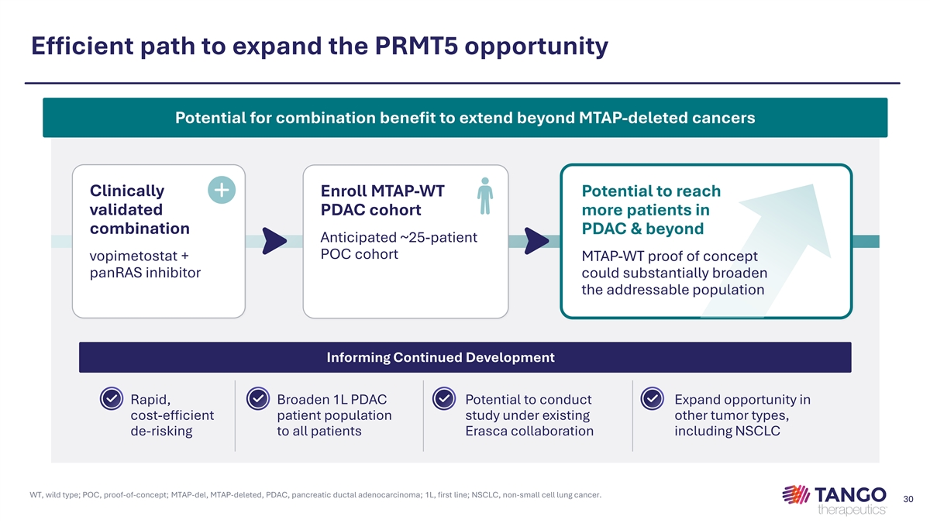
Efficient path to expand the PRMT5 opportunity Potential for combination benefit to extend beyond MTAP-deleted cancers Clinically Enroll MTAP-WT Potential to reach validated PDAC cohort more patients in combination PDAC & beyond Anticipated ~25-patient POC cohort vopimetostat + MTAP-WT proof of concept panRAS inhibitor could substantially broaden the addressable population Informing Continued Development Rapid, Broaden 1L PDAC Potential to conduct Expand opportunity in cost-efficient patient population study under existing other tumor types, de-risking to all patients Erasca collaboration including NSCLC WT, wild type; POC, proof-of-concept; MTAP-del, MTAP-deleted, PDAC, pancreatic ductal adenocarcinoma; 1L, first line; NSCLC, non-small cell lung cancer. 30


Upcoming milestones and financial highlights Matthew Gall, Chief Financial Officer 31

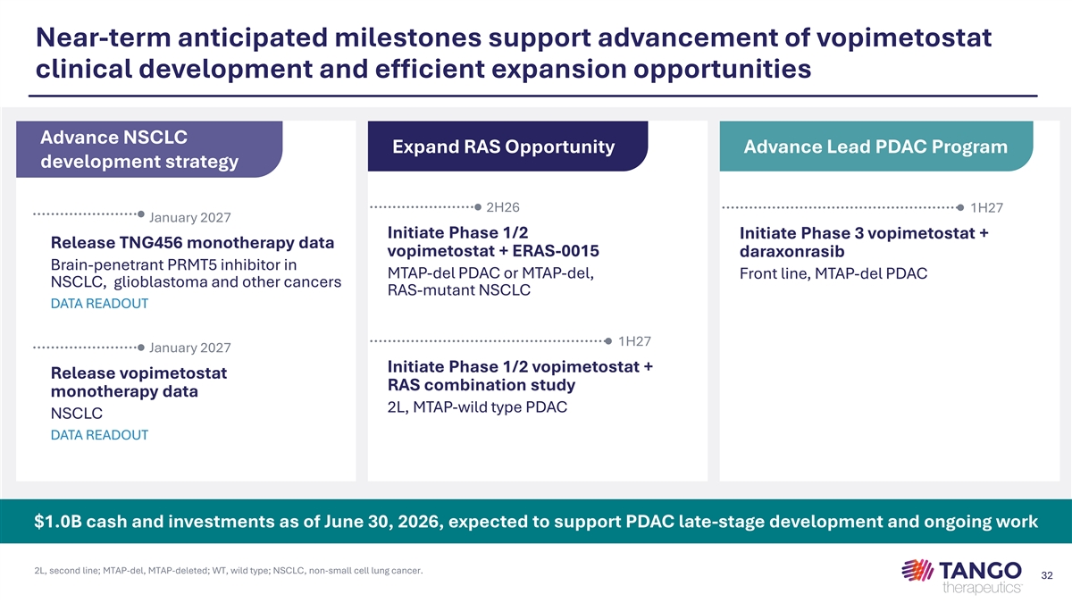
Near-term anticipated milestones support advancement of vopimetostat clinical development and efficient expansion opportunities Advance NSCLC Expand RAS Opportunity Advance Lead PDAC Program development strategy 2H26 1H27 January 2027 Initiate Phase 1/2 Initiate Phase 3 vopimetostat + Release TNG456 monotherapy data vopimetostat + ERAS-0015 daraxonrasib Brain-penetrant PRMT5 inhibitor in MTAP-del PDAC or MTAP-del, Front line, MTAP-del PDAC NSCLC, glioblastoma and other cancers RAS-mutant NSCLC DATA READOUT 1H27 January 2027 Initiate Phase 1/2 vopimetostat + Release vopimetostat RAS combination study monotherapy data 2L, MTAP-wild type PDAC NSCLC DATA READOUT $1.0B cash and investments as of June 30, 2026, expected to support PDAC late-stage development and ongoing work 2L, second line; MTAP-del, MTAP-deleted; WT, wild type; NSCLC, non-small cell lung cancer. 32

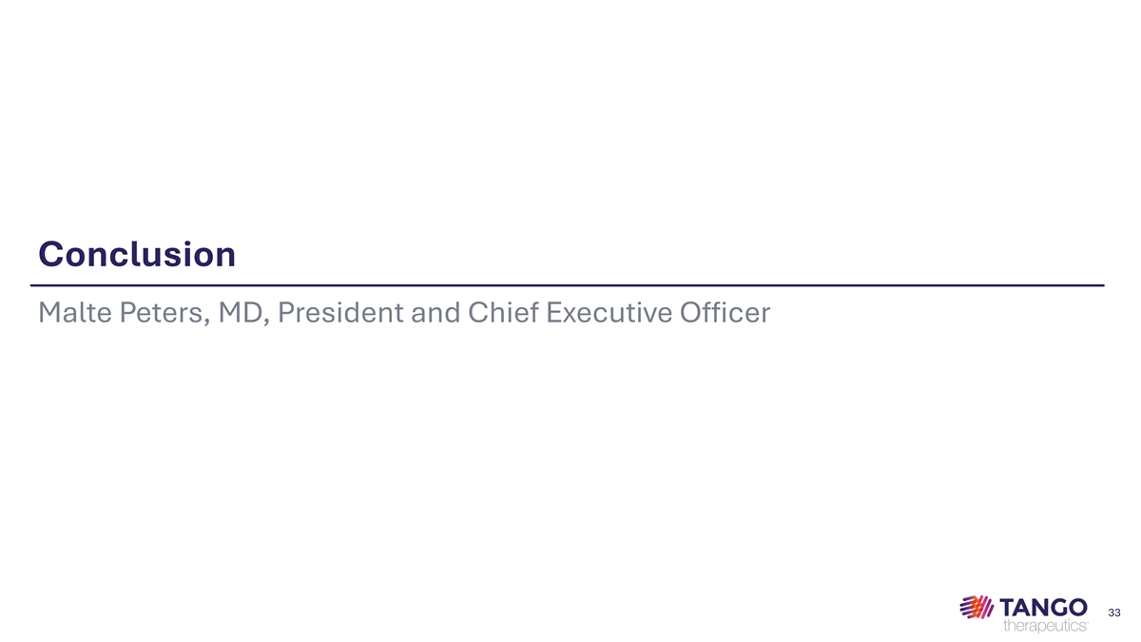
Conclusion Malte Peters, MD, President and Chief Executive Officer 33

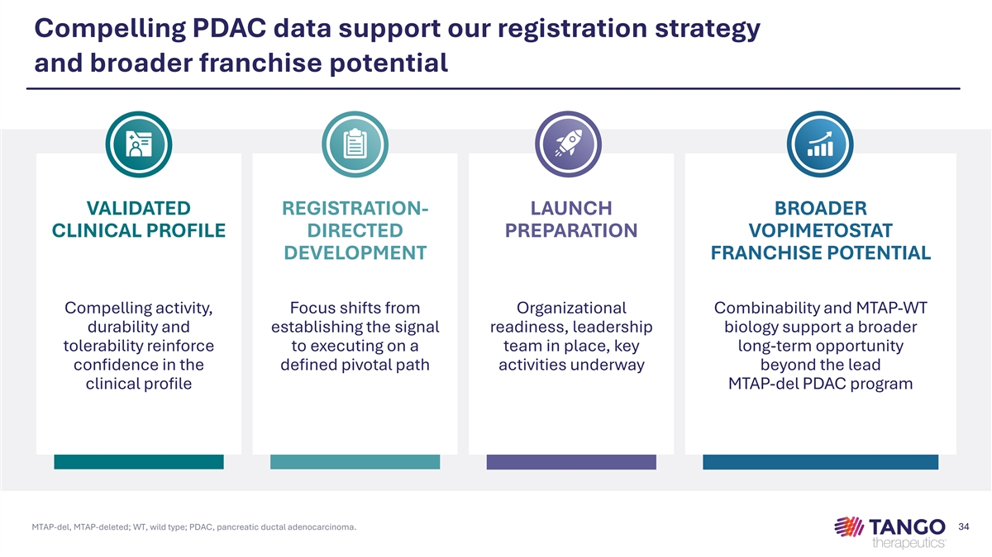
Compelling PDAC data support our registration strategy and broader franchise potential VALIDATED REGISTRATION- LAUNCH BROADER CLINICAL PROFILE DIRECTED PREPARATION VOPIMETOSTAT DEVELOPMENT FRANCHISE POTENTIAL Compelling activity, Focus shifts from Organizational Combinability and MTAP-WT durability and establishing the signal readiness, leadership biology support a broader tolerability reinforce to executing on a team in place, key long-term opportunity confidence in the defined pivotal path activities underway beyond the lead clinical profile MTAP-del PDAC program MTAP-del, MTAP-deleted; WT, wild type; PDAC, pancreatic ductal adenocarcinoma. 34



